TEACHING AND LEARNING CASE STUDY
Name of Institution | University College Cork
Who led the initiative? | Collaboration between Centre for the Integration of Research, Teaching and Learning (CIRTL), Office of Sustainability and Climate Action, and Green Campus
Date and timeframe of the initiative | 2019-2024  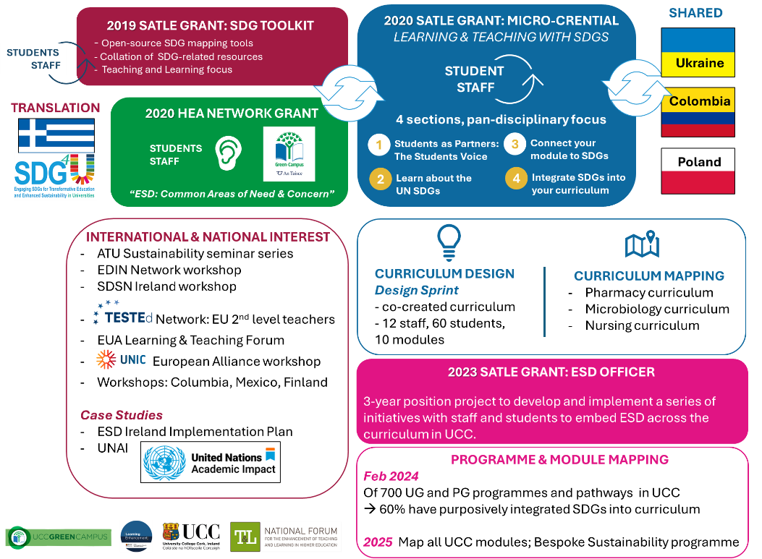
What was the reach of the initiative?
  SDG Toolkit | The SDG Toolkit has had over 21,000 website viewers  - 42.2% UCC  - 15.9% other Irish  - 24.4% other OECD (UK largest)  - 7.9% non-OECD Global North  - 9.6% from Global South  Invitation to share work as national and international case study of good practice.  - Case study in Ireland’s second national implementation plan for the SDGs  - Case study for UN Academic Impact
  ESD Consultation | 2 workshops were run by UCC Green Campus and Green-Campus Ireland. 54 registrations.
  Micro-credential | 50 graduates of short course since 2023 launch and hundreds of staff use parts of the course as a resource in developing their teaching practice.  The content of the short course has been shared with colleagues across the island of Ireland and has informed the development of the following:  - revision of the National Forum Digital Badge on ESD,  - refocusing of the UNIC European University Alliance to bring in an ESD focus in its second phase.  - Collaboration on ERASMUS+ project (SDG4U) to translate the UCC’s SDG toolkit for Greek HE network  - design of ESD offerings in Colombia, Poland & Ukraine  17 CPD workshops to approximately 500 teaching staff members in UCC and many Irish HEIs. Invited workshops were held in Mexico, Colombia, Sweden, UK, the Netherlands and Germany.  CONFERENCES/EVENTS  Successful submission and presentation at conferences and events:  - 3 institutional events for UCC staff, e.g. Quality Enhancement Unit’s Good Practice Symposium  - 7 national events  - 10 International conferences, including the 2021 EUA Learning and Teaching Forum.  PUBLICATIONS  1 open source CC SDG Toolkit for Teaching and Learning  1 book chapter  2 journal articles:  1 Masters Thesis in Teaching and Learning in Higher Ed
  ESD Officer | 60% of UCC programs (n=700) show purposeful SDG integration on completion of SDG mapping activity by in February 2024. This full report (due December 2024) will provide details on which SDGs are more common in which discipline. It will also identify which disciplines could integrate the SDGs further and provide an evidence base for directing the energies of the ESD Officer.
Initiative Title | Integrating Education for Sustainable Development in UCC: toolkits, digital badges and people
Aims/ Objectives | Aim: This case study draws on four different strands of work which collectively respond to the aim to equip teaching staff to develop and review curriculum offerings to integrate sustainability into teaching and learning.  Objective 1: Enact desk-based research and consultations with students and staff to shape the design and subsequent development of an online SDG Toolkit for Teaching and Learning and related 90-minute workshop.  Objective 2: Consult with staff and students through the 52 further and higher education partners that comprise the Irish Green Campus network to surface the challenges and opportunities that exist in our current teaching and learning system in relation to integrating a comprehensive Education for Sustainable Development (ESD) curriculum across all third-level education institutes in Ireland.  Objective 3: Develop a self-paced, flexible professional development offering to support staff to think reflectively, to learn with peers and craft curricula to support the participatory modes of engagement required to effectively integrate the SDGs into assessment, teaching and learning and establish action-oriented approaches.  Objective 4: Recruit an Education for Sustainable Development Officer and enact and ambitious plan to develop and implement a series of initiatives with staff and students to embed education for sustainable development across the curriculum in UCC.
Rationale and Identified Needs | Higher Education plays a critical role in advancing the aims of Education for Sustainable Development and realising the ambitions of the SDGs. Barriers to whole institutional integration of Education for Sustainable Development include disciplinary silos, insufficient funding, staffing and political will as well as external competitiveness between higher education institutions.  Addressing the SDGs in higher education requires a “whole-institution” approach, and students are increasingly looking to their universities to address challenges such as climate action and sustainability. Educators are being encouraged to bring their curriculum in line with this global agenda. The initiatives that comprise UCC’s work since 2019 has had the primary goal of ensuring students graduate from UCC with an education that teaches them not just the “what” of sustainable development, but the “how” and the “why”. These “global citizens” will be more employable to the increasing number of organisations placing a priority on sustainability as well as being more empowered in themselves to act to make the world a more sustainable and equitable place.  This initiative emerged out of the growing need for universities to be leading agents of change in response to a number of global challenges and exemplars of practice in response to interconnecting global challenges of the climate and biodiversity crisis and shifts in human migration. UCC had also launched an ambitious curriculum framework to support students to uncertain futures which required supporting staff to both implement changes in pedagogical practice as well as enable data driven resourcing and decision making for institutional leadership through mapping areas of strength and scope for development.  Desk research, consultations with staff within UCC and across sector indicated key bottlenecks such as skills and knowledge, time, funding and resources and engagement. While not all of these are resolvable. This initiative sought to advance small steps in the provisions of supports and resources. The AASHE STARS 2018 report provided a useful baseline also from which to advance this work.  Self-determination theory maintains that individuals are motivated by their need for competence, autonomy and relatedness. This initiative supported both novices and experts in gaining mastery in integrating sustainability in their teaching through the development of an open source, evidence-based toolkit and a co-created short course. It encouraged staff autonomy and choice through providing self-evaluation mapping tools to use for modules and programmes. It encouraged staff to care for and feel part of a growing ESD community through curating high-quality examples of practices from peers across the university and providing multiple spaces for staff and students to connect on the co-creation of the curriculum. This work of cultivating a community of practice amongst colleagues and students and community continues under the stewardship of UCC’s new ESD Officer.  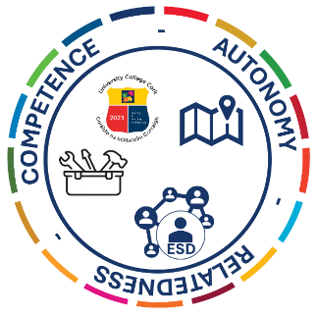  Through the SDG toolkit project, a range of resources were developed to support staff integration of SDGs. The SDG toolkit was publicised through running workshops for staff and proved very popular. However, feedback from the workshops and the SDG Toolkit advisory team highlighted the need for a longer, paced development for staff expanding to a 24 hour micro-credential. This would be offered as a hybrid course through Canvas augmented by synchronous sessions to foster transdisciplinary dialogue and establish a learning community where wicked problems could be addressed. Videos of institutional best practice will be created as inspirational case studies for staff to reflect upon their practice. Additionally, students would have a co-creational platform to express their needs and aspirations. The hybrid format will demonstrate the use of web-based tools and virtual pedagogies to advance online delivery in the current/post COVID-19 learning environment.  Both the national ESD consultation and ongoing evaluative feedback from staff confirmed the need of dedicated support and focussed expertise to bring this work on even further and that has been realised in hiring of the new ESD Officer, Dr David Nyaluke for UCC.
Frameworks, Policies, or Strategies Aligned  (internal, local or national) | - UCC Institutional Strategic Plans 2017-2022 & 2023-2028  - UCC Academic Strategy 2018-2022 and Connected Curriculum framework  - UCC Sustainability Strategy 2018-2022  - UCC Sustainability and Climate Action Plan 2023-2028  - Second National Strategy on Education for Sustainable Development: ESD to 2030  - Ireland’s Second National Implementation Plan for the SDGs 2022-2024  - Ireland’s 2023 Voluntary National Review: Sustainable Development Goals  - The 2030 Agenda for Sustainable Development and its SDGs  - European Sustainability Competence Framework  - UNESCO Education for Sustainable Development Goals: Learning Objectives (including key competencies for sustainability)
Summary | This case study captures a four-part initiative at University College Cork to equip staff to integrate a sustainability focus in teaching and learning. This approach responds to the needs of individuals for competence, autonomy and relatedness to unlock motivation. First, an online resource was provided which curated high quality, pan-disciplinary examples of curricular integration of the SDGs, and mapping tools were created to enable staff to engage in self-evaluation of their own modules and programmes.  A longer-form staff development offering was then created in response to the staff’s request for workshops of longer duration and a national consultation to surface needs relating to education for sustainable development with staff and students. Participants in micro-credential were encouraged first to connect to purpose through hearing from and soliciting students’ perspectives on the imperative to integrate sustainability in the curriculum. Participants then engaged in the stepwise redesign of teaching culminating in full module redesign.  Both the SDG toolkit and micro-credential emphasize the importance of staff deciding, or exploring with the students, the extent to which sustainability could be integrated in their modules and programmes. It provides support for both novice and expert and the examples of practice shared reflect a wide range of disciplines and inter-disciplinary contexts.  The next phase of this work focusses on strengthening confidence and competence, and growing connections between colleagues to create fertile ground and consistent support for further integration of sustainability.  A feature of this case study has been the growing emphasis on co-creation with students as the initiative matured. This co-creation effort began in the toolkit, developed further in the student partnership work in the micro-credential and subsequent curriculum design sprints with staff and students, and will be further developed under the leadership of the new ESD Officer.  In tandem with this internally focused work, was the desire to connect with colleagues across Ireland and around the world. This outward focus has been invaluable. It has ensured that the outputs of the project have resonance beyond the UCC community. It has sharpened the critical and reflective perspectives of initiative partners, so the resulting resources are considerate of decolonizing principles, key sustainability policies and frameworks, draw on sound pedagogical understanding, and are imbued with exciting practice examples.  This case study reflects almost 5 years of work and is a core commitment and central focus for our institution as well as providing an enriching and highly collegial work focus for all those involved in the initiative to date.
Did you collaborate with internal and/or external stakeholders to deliver? | Internal Stakeholders  SDG Toolkit: Advisory group drawn from ESD practitioners across UCC  Micro-credential: partnership with Students Union, Green Campus (student led initiative), academics engaged in ESD related activities.  ESD Officer: Systems Admin staff; Associate VP for Sustainability; Office of Sustainability and Climate Action; Student Societies; Students Union; Programme Directors in UCC Futures.  External Stakeholders  SDG Toolkit & Micro-credential: TESTEd project partners; SDG4U project partners; UNIC European University alliance members; SDSN Ireland network; National ESD Network; EDIN Network; participants on national ESD digital badge; participants on national community engaged learning digital badge  ESD Consultation: National Green Campus network and An Taisce
Organisation and Planning
  SDG Toolkit  Mar-Aug 2020  Sep-Feb 2021 | Recruitment of RSO; Advisory board established  Consultations with staff and students via workshops and feedback sessions  Development of mapping tools & resource curation  Pilot of toolkit with advisory board  Redevelopment of tool kit based on feedback  Soft launch of toolkit and roll out of workshops
  ESD Consultation  February 2021  Feb 2022 | Recruitment of facilitator for ESD consultations  Roll out of consultations and gathering of inputs  Finalising of report  Report launch and dissemination
  Micro-credential  November 2021  February 2022  April 2022  July 2022 | Formation of project team to write grant proposal  Recruitment of RSO; Advisory group  Recruitment of student partner on project  Development of digital badge application  Identification of exemplar practices and recording staff and student interviews  Development of online course and curation of materials  Development of formative assessment to encourage scaffolding of skills and knowledge as participant progresses through programme.  Finalising of course and launch.
  ESD Officer  March 2023  July 2023  September 2024 | Consultation with key contacts regarding scope of role.  Development of detailed work plan for position. Submission for review by University Leadership.  Repeat recruitment process as unsuccessful first time.  ESD officer in position.
What resources did you need? | STAFFING  Research Support Officer, John Barimo: SDG Toolkit  Research Support Officer, Niamh Guiry: ESD Consultation with Green Campus  Research Support Officers, John Barimo and Niamh Guiry, Micro-credential  Education for Sustainable Development Officer: David Nyaluke (new post)  NON-PAY  SDG Toolkit: refreshments for workshops, website design; travel costs  ESD Consultations: refreshments for workshops; graphic design on reports; travel costs  Micro-credential: Video recording and editing of video case studies; graphic design; travel costs; poster printing costs; SDG physical badges for badge graduates.  ESD Officer onboarding: Training in facilitation of 2030 SDG Games; travel to training. Support for attendance at national ESD forum. Co-funded seminar on ESD and curriculum.
Has it been evaluated? How successful has it been? | Modular Integration  The 2022 AASHE Sustainability Tracking, Assessment and Rating System evaluation revealed that ESD integration within undergraduate and graduate modules in UCC increased from 5.7% in 2018 ASHE STARS repot to 10.7%. Although we cannot infer a cause-and-effect linkage to the SDG toolkit and CPD per se, it is likely a contributing factor combined with institutional strategies reaffirmed in UCC’s most recent strategic plan (UCC 2023), UCC’s evolving institutional sustainability culture, and the increased societal awareness of global crises rooted in unsustainable practices.  Toolkit Engagement  The SDG Toolkit website was provisionally launched in August 2021 and formally launched at a national level in November 2021. To date, there have been 20,700 SDG Toolkit viewers with 58.1% from Ireland, 24.4% from other Organisation for Economic Co-operation and Development (OECD) countries, and 9.6% from Global South Nations with 0.4% of overall total from the UN list of least developed nations.  Evaluation of ESD Workshops  A total of 17 professional development workshops on ESD were presented to approximately 500 teaching staff members and the feedback from these workshops has been overwhelming positive (see Table below and qualitative statements).  Survey results  Qualitative statements  ▪ “The workshop encouraged me to explore the whole breadth of SDGs instead of focusing on a narrow selection that initially seemed most relevant.”  ▪ “Would be good to have more workshops like this and here of examples where people have included and integrated the SDGs in their modules.”  ▪ “John made the talk very informative and allowed us to learn from him and from each other. I will be recommending changes to the programme I manage based on my learnings from this excellent training. Thank you.”  ▪ “Great initiative. The tool needs refining - there are some inconsistencies and the max calculation seems a bit too simplistic. I have suggested for a number of years that there should be a compulsory SDG module for all first-year undergrads in S1 which could be adapted to each school. This would provide the ▪foundation for the SDG-linked modules and help to prevent lecturers repeating the SDG basics.”  ▪ “Plan to make changes to module descriptors/learning outcomes for next year.”  “Think there are definite synergies between embedding the SDGS and the graduate attributes into the curriculum and I am looking forward to exploring this further in due course. Thank you!”  ▪ “Useful to have a case study/ies to review after the session.”  Programme Mapping  From February of 2024, Programme Directors in UCC were prompted to map their programmes to the SDGs via the internal programme management software. The Programme Directors were required to only select for SDGs and related targets that score 2 or higher on this scale. The 6-point scale for mapping SDGs is based on UCC's Connected Curriculum self-assessment.  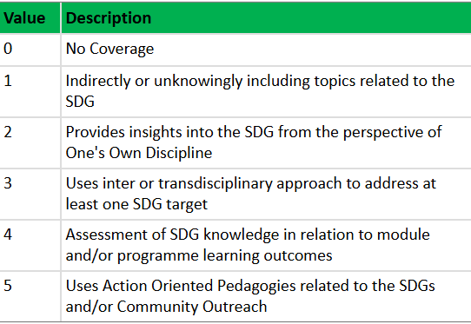  The results of this whole-institutional mapping of programmes to the SDGs indicate that 435 programmes of the 700 approved programmes, pathways, exit awards, were mapped to the SDGs. This suggests that 60% of UCC’s programme “provide insights into the (identified) SDG from the perspective of one’s own discipline”. This contrasts with the 2018 AASHE STARS report which showed that “only 6% of UCC modules addressed SDGs in a way that is ‘focussed’ or ‘related’”. This mapping activity work will continue with modules in 2025, and the programme and module reports need to deeper analysis and corroboration, which the new ESD Officer is currently undertaking. It is intended that the resulting report will uncover areas of strength, areas of development and areas where targeted support can lead to great acceleration in the development of curricula attuned to sustainability.
  How would you describe your background with Education for Sustainable Development and the SDGs? | Novice = 27% | Intermediate = 64% | Advanced = 9%
  Was there sufficient background content provided within the workshop? | Needs More = 9% | Just Right = 91% | Too Much = 0%
  Was the module mapping tool helpful for identifying SDG linkages to your module? | Very Helpful = 73% | Moderately Helpful = 27% | Not Helpful = 0%
  Did this workshop help you identify ways you can introduce SDGs or expand the treatment of SDGs within your module? | Yes = 82% | No = 18%
Any future plans, including the sustainability of the initiative? | The ESD Officer position is currently working with staff who have completed the micro-credential to gain insights into what curricular changes they have made, how students responding, what their own learning, support needs and future ambitions are. They are also supporting the development of a new undergraduate programme on sustainability and will work in support of other postgraduate offerings in this area. Through this mix of broad support and bespoke consultancy will hopefully connect this work and curriculum development to a wider range of actors.  Future work would expand reach of the open-source SDG toolkit in a broader all-island context. The ambition is to create a collaboratively redesigned toolkit under the auspices of SDSN Ireland given its all-island remit thus removing the tendency towards replication and proliferation of multiple toolkits to ensure equal access to all HEIs. This would be achieved through facilitating consultations within each HEI across the island of Ireland to critically examine the existing toolkit and gather feedback on its redevelopment/redesign. This could culminate in a national deliberative assembly to agree the final design and reach consensus.  The primary benefit would be to gain insight into what practices and approaches are being advanced in the various HEIs nationally and to foster a collaborative and appreciative spirit and shared sense of ownership of a resource to support all. This approach will also support shared degrees programmes, e.g., HCI funded Sustainable Futures programme. An additional benefit of such an approach would be to support the development of a nascent ESD network.  Given the world-wide uptake of this SDG Toolkit, especially in the Global South, a resource could also be re-created without localised or regional context. This would be co-designed and disseminated by the global network of 57 national/regional SDSNs, collectively functioning under the auspices of the United Nations Secretary General.
Key Learning Points | 1: Many staff are already engaged in efforts that integrate sustainability in the curriculum but do not necessarily use that language nor frame their work in that way. Curating examples from a wide range of disciplines is vital for showing what is possible and to illustrate small changes that can begin these efforts.  2: The focus on SDGs taken in UCC ensured staff were working within a more bounded frame, rather than the broad ESD focus. The SDG framework and targets provided a comprehensive road map and transdisciplinary language, as well as a useful point of comparison and space for critique.  3: This work can make staff feel uneasy, especially when there is a less clear disciplinary fit. Providing several opportunities to connect, space and tools to map one’s discipline and teaching, and sharing a wide range of examples ensured people felt confident to take a first step.  4: Our students are our strongest advocates in this work as well as often holding a depth of knowledge on these topics. Partner with them in the redesign or reorientation of teaching and learning wherever possible.

Teaching and Learning Focus Areas (please tick all that apply)
Categories | Elements | Topics | Target Groups
Commit ☐ | Leadership, Strategy & Governance ☐ | Digital Transformation ☐ | Students ☒
Coordinate ☒ | Curriculum and Assessment ☐ | Education for Sustainable Development  ☒ | Staff ☒
Consult ☒ | Innovation in Teaching☒ | Academic Integrity  ☐ | Wider community ☒
Create ☒ | Professional Development ☒ | Inclusive and Equitable Teaching Practices  ☐ | Other ☐
Celebrate & Continue ☐ | Research and Evaluation ☐ | Innovations in Assessment and Feedback  ☒
Student Engagement and Partnership
☒
Collaborative and Interdisciplinary Approaches
☒
Artificial Intelligence
☐
Other
☐

Contact Details
Contact Name/s | Catherine O’Mahony and David Nyaluke
Date | 15/11/2024
Email Address | Catherine.omahony@ucc.ie; Dnyaluke@ucc.ie
Links | RESOURCES  Open-source SDG Toolkit for staff: www.ucc.ie/en/sdg-toolkit/  Micro-credential: Learning and Teaching with the SDGs www.ucc.ie/en/greencampus/practice/teaching-and-learning/  PUBLICATIONS  CASE STUDIES  UNAI Case Study: www.un.org/en/academic-impact/enhancing-sdgs-related-teaching-irish-university-offers-open-source-toolkit  National ESD Implementation Plan Case Study: www.gov.ie/pdf/?file=https://assets.gov.ie/238357/74386d7f-167d-402e-82b9-4eb71b3077db.pdf#page=null  REPORTS  “Education for Sustainable Development - Co-creating Common Areas of Need and Concern” report based on national ESD consultation. www.greencampusireland.org/education-for-sustainable-development-co-creating-common-areas-of-need-and-concern/  RELATED GRANTS  Erasmus+ TESTEd (Towards a European Syllabus in Teacher Education): https://tested-network.eu/  Erasmus+ grant SDG4U (Engaging SDGs for transformative education and enhanced sustainability in universities): www.sdg4uproject.eu/
ACKNOWLEDGEMENTS
This case study reflects the creativity, expertise and endeavors of a much broader group and the following colleagues were key to the success of this initiative to date and are essential to its future impact.
  Dr John Barimo  Manager of SDSN Ireland | Niamh Guiry  PhD Student | Dr Maria Kirrane  Head of Sustainability and Climate Action | Dr Gerard Mulally  Lecturer Department of Sociology & Criminology | Dr Catherine O’Mahony  Director of Teaching and Learning Centre | Dr David Nyaluke  Education for Sustainable Development Officer

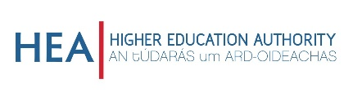
This work was supported by the National Forum and HEA from 2019-present

