TEACHING AND LEARNING CASE STUDY
Name of Institution/ Organisation | Trinity College Dublin
Who led the initiative? | Centre for Academic Practice, Trinity College Dublin.
Date and timeframe of the initiative | Academic Year 23/24, 24/25 and ongoing.
What was the reach of the initiative? | Staff involved in teaching, learning and supporting students in Trinity College Dublin and across the Higher Education sector in Ireland
Initiative Title | Using GenAI for teaching, learning and assessment.
Aims/ Objectives | - Help teaching staff understand GenAI and how it works;  - Illustrate how GenAI can be used in teaching, learning, assessment and research;  - Identify risks and challenges to be considered when using GenAI.  - Provide guidance on how GenAI is currently used ethically and responsibly to enhance teaching, learning, assessment and research in higher education
Rationale | While generative artificial intelligence (GenAI) technologies have existed for many years, recent advances in the field have resulted in the mainstream use of these technologies across society, leading to many opportunities and challenges for universities across the world.  Initial institutional responses focused on potential threats to academic integrity, and GenAI has significant implications in this regard. However, it is becoming increasingly evident that these developing technologies also present significant opportunities for teaching, learning and assessment in higher education.  Given this, it is essential that as educators, we have a clear understanding of the capabilities of GenAI, and the potential implications of these technologies for how we teach, learn, and assess in higher education.  There is a need for policies and guidelines from national bodies and individual institutions on the ethical and responsible use of GenAI in higher education.
Frameworks, Policies, or Strategies Aligned  (internal, local or national) | - Trinity College Dublin Strategy 2020-2025  - Digital Transformation in Trinity College Dublin (SATLE)  - National Academic Integrity Network’s GenAI Guidelines for Educators  - UNESCO guidelines for higher education and research  - PAIR framework  - Traffic light model for GenAI in assessment
Summary | Trinity's GenerativeAI Action Plan outlines different levels of how to integrate AI into the institution responsibly and ethically. This initiative is designed to support and enhance teaching practices to support a more inclusive and engaging learning experience through developing AI Literacy in academic staff.  The different levels are:  - the creation of open resources to support embedding GenAI in teaching, learning and assessment, which includes exploratory practices from the disciplines;  - professional development, which includes webinars, workshops, brown-bag lunch events and the development and implementation of an open course (The National Forum): Using GenAI in T&L: how to do it right?;  - leading a national publication in collaboration, with the other six universities in Ireland, gathering explorative practices from a wide range of disciplines.
Did you collaborate with internal and/or external stakeholders to deliver? | Internal:  Trinity Business School GenAI taskforce; Trinity Digital Learning Development.  External:  Dublin City University, University of Limerick, University College Cork, University of Galway; University College Dublin; Maynooth University, TU Dublin, National Academic Integrity Network.
Organisation and Planning | Please see 1-organisation-planning.png image for a diagram of our planning and phases.
What resources did you need? | HEA National Forum:  - SATLE project funding  - OpenCourses funding (Dublin City University and University of Limerick)  Staff:  -Centre for Academic Practice  -Digital Learning Development  -Representatives from the external university stakeholders
Has it been evaluated? How successful has it been? | Evaluation phase of the strategy will take place in academic year 2025/26.
Any future plans, including the sustainability of the initiative? | - Evaluation phase  - Rollout of the GenAI OpenCourse through the National Forum network and other international higher education networks  - Continue embedding GenAI in professional development formal and informal opportunities
Key Learning Points | - Interinstitutional collaboration works very successfully in this area as we are all facing similar challenges and opportunities with GenAI  - Leading innovation in teaching and learning requires reflection, openness, dialogue and project management.  - Professional development is required in order to meet the changing educational landscape due to GenAI  - The rapidly-evolving nature of GenAI requires continuous renewal and review of guidelines and resources for staff involved in teaching.

Teaching and Learning Focus Areas (please tick all that apply)
Categories | Elements | Topics | Target Groups
Commit ☒ | Leadership, Strategy & Governance ☒ | Digital Transformation ☒ | Students ☐
Coordinate ☒ | Curriculum and Assessment ☐ | Education for Sustainable Development  ☐ | Staff ☒
Consult ☒ | Innovation in Teaching☒ | Academic Integrity  ☒ | Wider community ☐
Create ☒ | Professional Development ☒ | Inclusive and Equitable Teaching Practices  ☒ | Other ☐
Celebrate & Continue ☐ | Research and Evaluation ☐ | Innovations in Assessment and Feedback  ☒
Student Engagement and Partnership
☐

Collaborative and Interdisciplinary Approaches
☒

Artificial Intelligence
☒

Other
☐

Contact Details
Contact Name/s | Dr Ana Elena Schalk (primary contact point); Dr Caitríona Ní Shé; Dr Pauline Rooney; Mr Kevin O’Connor; Dr Claire McAvinia.
Date | 14/11/2024
Email Address | schalka@tcd.ie
Links | Please add links to any relevant pages/ documents. Please attach any items not in a link format with your submission.  - Plan: (a readable version of the image is at the end of this document)  - Open Resources: https://www.tcd.ie/academicpractice/resources/generative_ai/  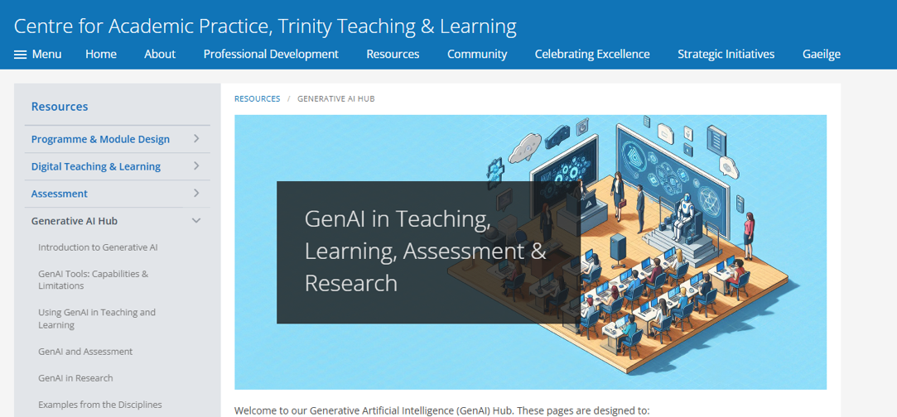  - Professional Development:  https://opencourses.ie/opencourse/genai-for-teaching-and-learning-how-to-do-it-right/  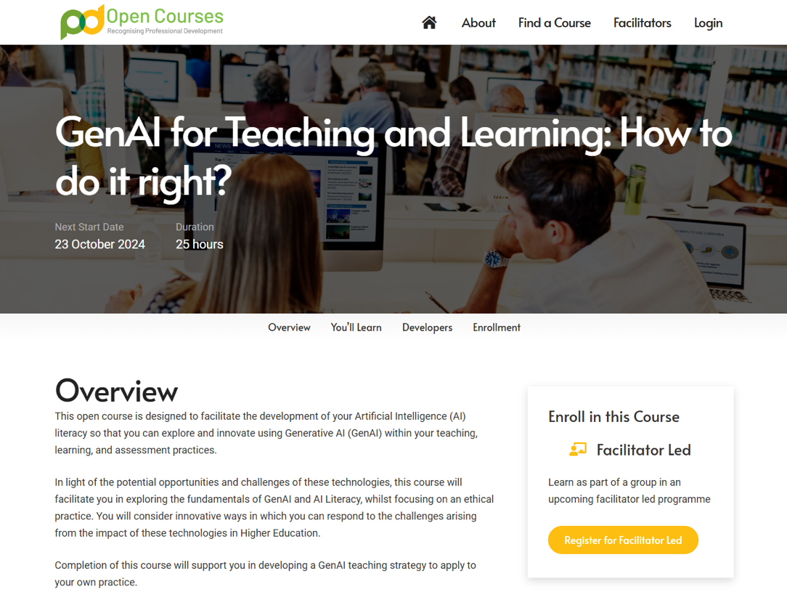  The Brown-Bag Lunch activity: https://www.tcd.ie/academicpractice/professional-development/workshops/events2425/brownbag.php  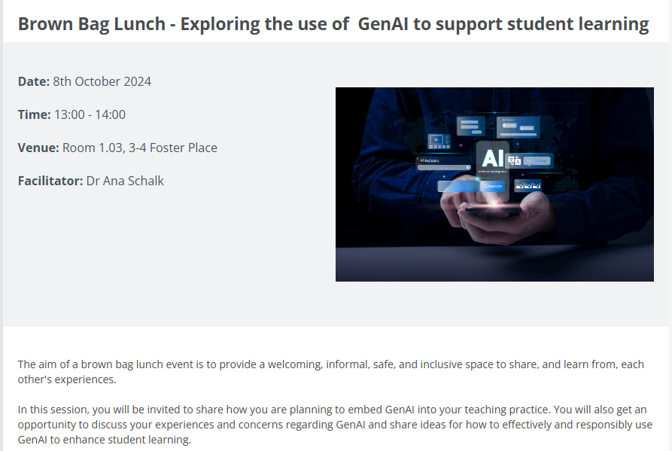  - Open-access resource Using GenAI in teaching, learning and assessment, explorative practices in Irish Universities.  Launching 23rd of January 2025.  