TEACHING AND LEARNING CASE STUDY
Name of Institution/ Organisation | TUS Library: Midlands  Technological University of the Shannon: Midlands Midwest    TUS logo. All rights reserved.
Who led the initiative? | Ms. Celine Peignen, Head Librarian TUS Midlands, project lead  Ms. Maura Flynn, OER Librarian, TUS Library  Dr. Nuala Harding, Head of the Centre for Pedagogical Innovation and Development (CPID)
Date and timeframe | 2023-current, ongoing.  Note: This project is building on earlier OER projects in TUS.
What was the reach of the initiative? | - TUS Library has delivered 170 information literacy sessions, inclusive of OER, in the 2023/2024 academic year.  - Incorporating OER and Open Access resources into these sessions enables us to broaden our reach significantly, with 2720 student and 275 TUS staff participants, during this period.  - The information provided below reflects dedicated OER educational and dissemination opportunities carried out in TUS and through the Developing Open Educational Resources for the Scholarship of Learning and Teaching (DOERs in SoTL) project.  - This project, the DOERs project, is resourced through the National Forum’s SATLE 2022 fund. TUS is leading this project, with partner higher education institutes (DkIT, Maynooth University and SETU).    DOERs logo. All rights reserved.  Training and awareness building sessions  Staff:  - Educational opportunities were developed based on the responses we received to our TUS OER survey, including face-to-face and online workshops and webinars, small group and peer learning.  - We also presented at a number of internal TUS meetings and have found this to be an efficient and effective engagement mechanism.  - Key stakeholders that we have engaged with include: SATLE Learning Enhancement Projects (LEPs) recipients; academic staff engaged with Teaching and Learning units; and library staff.  - The total number of staff who engaged in dedicated OER educational opportunities, to date in this period, is 198.  - Our focus was predominantly to engage with staff and this knowledge will be shared with students, as is exemplified by this training attendee feedback: “I will be explaining the concepts of the Creative Commons license to our students who have worked on the project so they can consider their work and any future work they create.”  Students:  - While student oriented OER training sessions were not an area of focus during this period, one dedicated student session was facilitated for 14 students, which was very positively received.  - Student involvement in OER utilisation, adaptation and co-creation is a key opportunity area for the future.  DOERs Workshop held in TUS  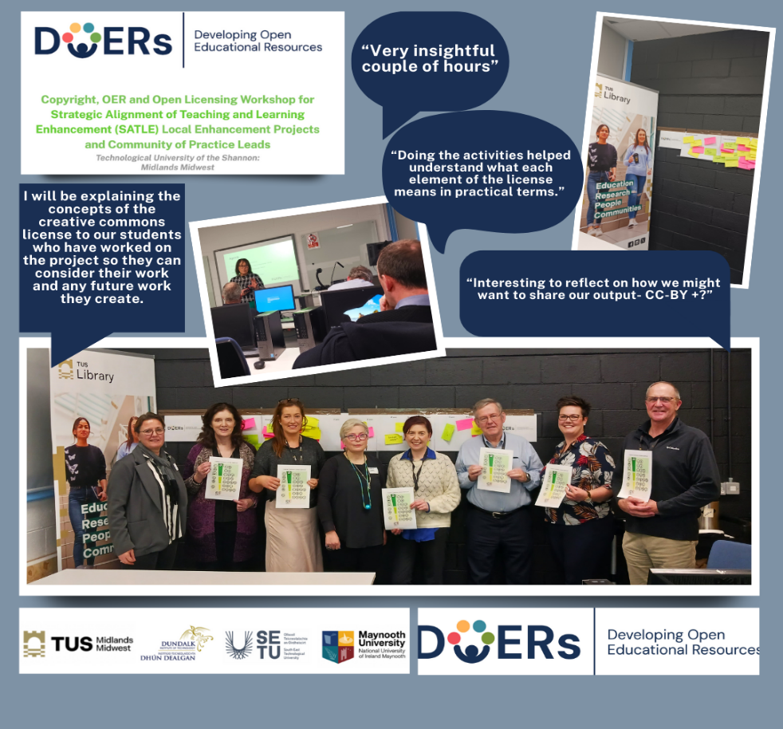  Asynchronous:  - We recognise the importance of asynchronous training resources and have created and shared OER webinar recordings and infographics.  Dissemination within the broader HE and Library community  - Conference presentations: EdTech 2023, OER24 and Academic and Special Libraries 2024.  - Membership of European Network of Open Education Librarians (ENOEL) and engaging in networking with Librarians in Ireland.  - TUS library is developing a workshop s with NHL Stenden for dissemination to RUN-EU partner universities in semester 2.  OER discoverability support  - This service supports our faculty in locating relevant OER to meet their needs. This is carried out upon request and can also be initiated by Library staff when they identify high quality, timely and relevant OER.
Initiative Title | Unlocking Knowledge at TUS: Advancing OER Awareness, Access, and Collaboration
Aims/ Objectives | The aims of our work, both in TUS and within our project partner DOERs sites (DkIT, Maynooth University and SETU) include:  - To raise awareness of Open Educational Resources (OER) and Open Educational Practices (OEP).  - To audit the level of use in each institution.  - To develop and design training material to promote OER and encourage their use.  - To empower staff who teach to develop OER and encourage collaboration.
Rationale and Identified Needs | - The concept of OER has long been advocated for, as is evident from the publication of the Cape Town Open Education Declaration (2007) onwards. In Ireland, the National Forum has advocated for Open Education, which encompasses OER, since 2014.  - There is clear alignment between OER and the UN Sustainable Development Goals, particularly: Quality Education (SDG 4); Reduced Inequalities (SDG 10); and Partnerships (SDG 17).  - Potential benefits of OER to our university include: reducing financial barriers to learning; creating inclusive, sustainable and accessible learning resources; enhancing the library collections by adding a variety of Open material and future proof the offerings; and enhancing student engagement and retention.
Frameworks, Policies, or Strategies Aligned | Our work aligns closely with international and national priority areas, including:  - The UN Sustainable Development Goals, particularly: Quality Education (SDG 4).  - The National Action Plan for Open Research, as the remit includes OER.  - A Sectoral White Paper by Jhangiani, R., Farrelly, T., Ó Súilleabháin, G. on behalf of NTUTORR, in 2024 (Open Education Practices in Higher Education: Focusing on Responsiveness, Innovation & Inclusivity)  - OER aligns with TUS value statements, as outlined in our Strategic Plan 2023-2026: inclusive; supportive; ambitious; innovative; sustainable; and collaborative. Similarly, OER will support strategic priorities, including: communication, technology and digitation; and sustainable development.
Summary | To achieve the aims outlined above, we focused upon:  - Dedicated resourcing – the creation of Ireland’s first dedicated OER Librarian post in TUS Library in 2023.  - Information gathering – we conducted surveys in the DOERs project partner sites to audit OER awareness and utilisation. The results of the survey informed our project planning and delivery. The survey questions are openly licensed and available on our Zenodo project page. A related infographic outlining our findings is available on Zenodo.  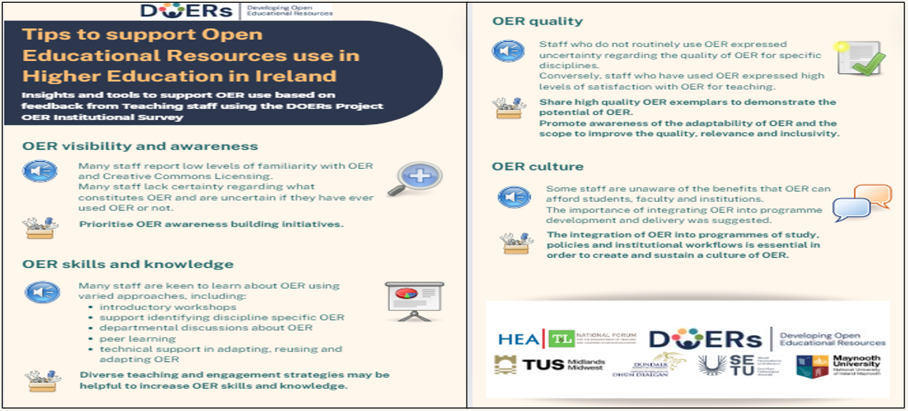  Tips to support Open Educational Resources use in Higher Education in Ireland – DOERs survey results infographic by The DOERs Project CC BY-NC 4.0  - Increased utilisation of OA and OER in our programmes – the Library advocates for this approach across our faculties, through our work engaging with programme development review processes, supporting new programme creation etc.  - Discoverability – TUS promotes access to OER through our second generation TUS OER Index and the creation of our Pressbook: Open Educational Resources for Teaching and Learning at TUS. Both tools were published in October 2024 to celebrate OA week and are living resources, which will be further developed over the 2024/2025 academic year. We prioritise the inclusion of OER created in Ireland.  - Creation - TUS Open Press using the Pressbooks platform to create engaging and interactive Web books. Pressbooks is being piloted by TUS staff. Feedback has been very positive and will inform how we develop the Open Press.  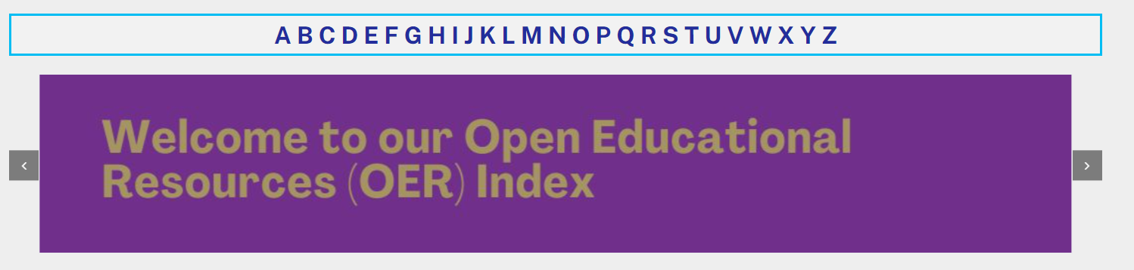  Snip of the second generation TUS OER Index by TUS Library. CC BY 4.0  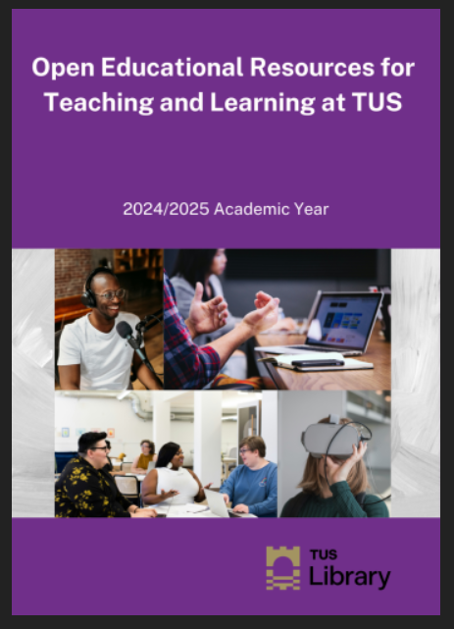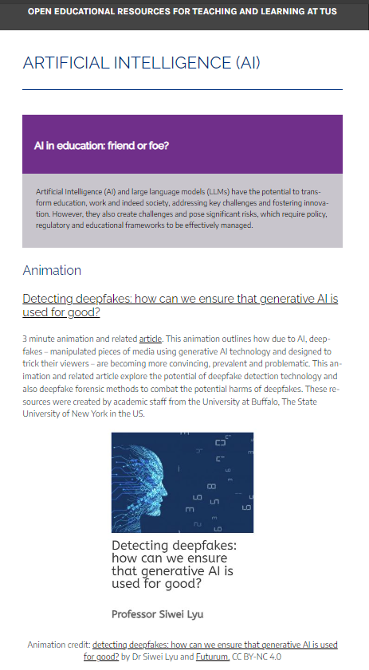  Left: Cover of the OER for Teaching and Learning at TUS Pressbook by TUS Library. CC BY NC 4.0  Right: Snip of content within the OER Pressbook Artificial intelligence (AI) – Open Educational Resources for Teaching and Learning at TUS by TUS Library. CC BY NC 4.0  - Education and training - we provide OER face-to-face and online workshops and training sessions.  - Collaboration – TUS is collaborating with DkIT, TUS, SETU and Maynooth University on the DOERs project.
Did you collaborate with internal and/or external stakeholders to deliver? | - TUS Library and TUS Centre for Pedagogical Innovation and Development (CPID) continue to partner with colleagues in TUS to promote OER.  - TUS Library also collaborate closely with TUS Quality Office to develop an OER policy to sit under the current OA policy. Our target is 10% inclusion in reading/resource lists.  - We collaborate with external partners externally, including our DOERs project partners and other HE partners nationally and internationally.    Collage of DOERs project member institutional logos. All rights reserved.
Organisation and Planning | A variety of approaches were used to organise and plan the project outputs.  TUS specific:  - Regular engagement is prioritised with key TUS stakeholders, including Deans and Heads of Department in TUS to support inclusion of OA/OER in reading material. The involvement of the OER Project Lead on programmatic review panels enables ongoing monitoring and advising on use and inclusion of OA/OER resources.  - Presentations are delivered to sub-committees of Academic Council each semester to report on progress.  - Weekly OER library meetings.  DOERs project:  - DOERs monthly meetings and a shared DOERs MS Teams space to facilitate collaborative working.
What resources did you need? | Library staffing roles and time:  - Dedicated OER Librarian post 2023-2025: this SATLE funded role aligns with recent NTUTORR recommendations which emphasise the importance of investing in dedicated staff positions to support institutional capacity building for OER. The remit for this role is to support TUS and DOERs project partners.  - Former library role of Deputy Librarian and Open Education Librarian: prior to the OER Librarian joining TUS Library in 2023, TUS developed the role of Deputy and Open Education Librarian to scaffold future OER developments.  - Continuing Professional Development: Library staff undertake ongoing OEP upskilling opportunities. Two Library staff members undertook the Creative Commons Certificate in January 2024, funded by the Library service and two additional TUS staff members are undertaking this certification through SATLE funding. The OER Librarian is also undertaking the UD Beyond the Classroom – Digital Badge.  Technology:  - OER Index: created using Wordpress, facilitated by EduCampus.  - TUS Open Press: using the Pressbooks platform, currently funded by the Library, but sustainable long term funding options are required.  - LibGuides platform: funded by the Library, this fool enabled the creation of a dedicated OER Library guide.  - Social media: Library social media accounts on platforms such as Instagram, Facebook and X, are used to promote OER. The hashtag #TUSOER is used for these posts. Emerging platforms, such as Bluesky, are being explored for their OER retrieval and engagement potential.
Has it been evaluated? How successful has it been? | Significant increases in OA and OER in TUS programmes: many faculties have made huge strides in this regard, with Library support, including Engineering.  - The Faculty of Continuing Professional Online and Distance Learning piloted an initiative to maximise the inclusion of OA and OER material in the reading lists, to date an average of 80% inclusion is recorded throughout all their programmes.  - Declan Doran, Head of Department, Continuing Professional Online and Distance Learning, TUS, shares the impact of this change on his faculty:  "By incorporating Open Access and Open Educational Resources into our online suite of programme resources, we've expanded opportunities for lifelong learners and online distant students to access essential materials anytime, anywhere. This shift has bridged gaps in accessibility, ensuring that all students, regardless of location, can engage with high-quality resources without financial or logistical barriers. The library's commitment to open content is fostering a more inclusive and empowering learning experience, transforming the possibilities for online and distant education and considerably enhancing the student experience".  Pressbooks feedback: the feedback from staff who are piloting our Open Press platform, Pressbooks, has been overwhelmingly positive.  - Dr Denise Mac Giolla Ri (PhD), Lecturer, Creativity in Social Care and Early Years Education and Care, TUS, outlines her experiences as follows: “The Pressbooks software interface is intuitive and user-friendly, making it easy to upload and convert documents efficiently. It is a highly suitable platform for my two current projects: first, developing a crowd-sourced eBook focused on creative and recreational practices for social good on both national and international levels; second, converting an existing PDF eBook into the Pressbooks format. The support, advice and information I have received from Maura Flynn in the TUS library have been invaluable, especially regarding Creative Commons licensing and the effective use of the software.”  OER training feedback: was invited from training participants using Google docs, Vevox and email.  - Pre and post test questions were incorporated into our presentations using Vevox, which demonstrate perceived improvement in OEP, OER and Open Licensing knowledge in light of the training.  - Jim Gilchrist, Lecturer in the Department of Lifelong Learning shares his experience: "Exploring open licensing and OER through the TUS Library has been a game changer in helping me share my AI in Educational Design case study. The library team demystified the process, showing me how to share my work effectively and ethically. It has facilitated my sharing of diverse, interactive content , while making the case study more accessible and engaging for a broader audience."  DOERs project: this initiative is ongoing across TUS and partner sites and will be evaluated. Project feedback to date has been overwhelmingly positive.
Any future plans, including the sustainability of the initiative? | Ensuring the long-term sustainability of the initiative is imperative.  Funding to enable the advancement of OER in TUS:  - Dedicated staffing and CPD opportunities  - Open Press continuity and OER and OEP incentives  Information gathering and liaison with key stakeholders:  - Conduct OER surveys at regular intervals to determine progress and opportunities.  - Establish an OER Community of Practice.  OER education, advocacy and dissemination  - We will continue to strongly promote and enhance the content of our TUS OER Index and TUS Open Press.  - We will continue to provide a range of training opportunities, both synchronous and asynchronous.  Partnerships  - We will continue to collaborate nationally and internationally.  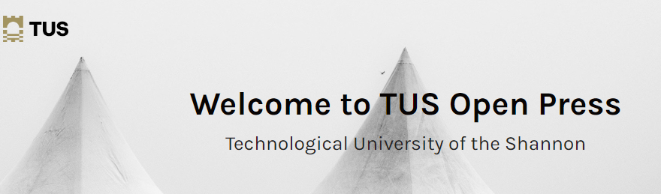  Snip of TUS Open Press by TUS Library. All rights reserved.
Key Learning Points | - There is a strong appetite for OER educational opportunities amongst our staff.  - Supporting staff to access high quality, recent and relevant OER is an important step in embedding OER within an organisational culture.  - The value of partnerships, particularly between the Library and our Teaching and Learning colleagues cannot be overstated. Collaborative working is essential to embedding OER within the culture of our organisations.

Teaching and Learning Focus Areas (please tick all that apply)
Categories | Elements | Topics | Target Groups
Commit ☐ | Leadership, Strategy & Governance ☐ | Digital Transformation ☒ | Students ☒
Coordinate ☒ | Curriculum and Assessment ☒ | Education for Sustainable Development  ☒ | Staff ☒
Consult ☐ | Innovation in Teaching☒ | Academic Integrity  ☒ | Wider community ☒
Create ☒ | Professional Development ☒ | Inclusive and Equitable Teaching Practices  ☒ | Other ☐
Celebrate & Continue ☒ | Research and Evaluation ☒ | Innovations in Assessment and Feedback  ☐
Student Engagement and Partnership
☒
Collaborative and Interdisciplinary Approaches
☒

Contact Details
Contact Name/s | Maura Flynn OER Librarian, Celine Peignen Head Librarian and project lead, Dr Nuala Harding Head of Department CPID
Date | 20th November 2024
Email Address | Maura.flynn@tus.ie , celine.peignen@tus.ie , nuala.harding@tus.ie

