TEACHING AND LEARNING CASE STUDY
Name of Institution/ Organisation | RCSI University of Medicine and Health Sciences
Who led the initiative? | Deputy Dean for Student Engagement (Professor Celine Marmion), Faculty of Medicine and Health Sciences
Date and timeframe of the initiative | 2018 – 2024 and ongoing
What was the reach of the initiative? | Since the launch of the StEP programme in 2020-2021, 178 staff (academic and professional) and 171 students have worked in partnership on a total of 68 StEP level 1 funded projects (10 week projects run during semester 2 with student contact capped at 3 hrs/week) and 41 StEP level 2 funded projects (8 week full-time projects during the summer).  The project outputs are far reaching. They span all four pillars of the StEP programme, from institutional management and key decision-making processes, teaching, learning and assessment, academic research and engagement with the local community and social environment.  They also contribute to the four themes within the RCSI strategy 2023-2027 ‘Innovating for a Healthier Future’, namely ‘Health and Societal Impact’, ‘Education and Student Success’, Research and Innovation’ and ‘Foundations for Sustainable Impact’.  Each StEP project also aligns closely to one or more of the following UN Sustainable Development Goals:  SDG 3: Good Health and Well-being  SDG 4: Quality Education  SDG 5: Gender Equality  SDG 8: Decent Work and Economic Growth  SDG 9: Industry, Innovation, and Infrastructure  SDG 10: Reduced Inequalities  SDG 11: Sustainable Cities and Communities  SDG 12: Responsible Consumption and Production  SDG 13: Climate Action  SDG 16: Peace, Justice, and Strong Institutions  SDG 17: Partnerships for the Goals  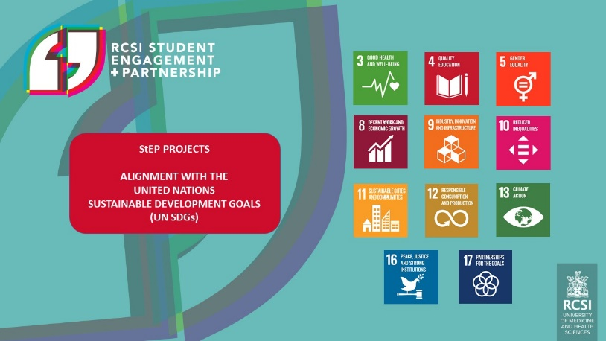  A significant number of StEP projects are also directly aligned to the HEA Higher Education Healthy Campus Charter and Framework
Initiative Title | RCSI Student Engagement and Partnership (StEP) Programme
Aims/ Objectives | To support RCSI’s strategic vision of embedding a universal culture of student engagement and partnership and, in so doing, provide a distinctive, vibrant and transformational educational experience that sets students up for success at RCSI and as future health science graduates.
Rationale and Identified Needs | A seminal report published in the Lancet Commissions in 2010 put forward  a vision and a series of recommendations to provide a transformative learning experience for healthcare professionals of the future. [1] It sought a transition from an informative learning environment where students acquire knowledge and skills ‘to produce experts’, to formative learning, socialising students around values ‘to produce professionals’ to transformative learning. This latter transformative approach focuses on nurturing and developing leadership attributes to produce ‘enlightened change agents of society’.  As a university with a singular focus on health sciences, we believe that promoting and nurturing a culture of student engagement and partnership ‘enables’ our students (and future health science professionals) to further develop their collaborative and leadership skills. This facilitates their development as ‘enlightened change agents’ with the capacity to truly influence and transform human health in the future. This was the rationale behind the development of the RCSI Student Engagement and Partnership (StEP) programme.  [1] J. Frenk, L. Chen et al., ‘Health professionals for a new century: transforming education to strengthen health systems in an interdependent world’, The Lancet Commissions, 2010, 376, 9756, 1923-1958; DOI: https://doi.org/10.1016/S0140-6736(10)61854-5
Frameworks, Policies, or Strategies Aligned  (internal, local or national) | The following are relevant internal, local, national and international frameworks or policies.  - RCSI strategy 2023-2027 ‘Innovating for a Healthier Future’  - National Student Engagement Programme (NStEP) strategy  - ASPIRE Award for Excellence in Student Engagement  - UN Sustainable Development Goals  - HEA Higher Education Healthy Campus Charter and Framework  - A Vision for Partnership – USI Student Engagement Policy
Summary | The RCSI Strategic Plan 2018-2022 placed student partnership as a core strategic enabler in striving to transform healthcare education, research and service for the benefit of human health. In striving to achieve this, RCSI appointed a Deputy Dean for Student Engagement in 2018 and a university-wide RCSI Student Engagement and Partnership (StEP) Committee was subsequently established. A formal StEP programme was launched in 2020-2021, which includes (i) a definition of student partnership in the context of RCSI, (ii) a bespoke RCSI StEP framework (Figure 1), (iii) formal StEP Agreements between RCSI and the SU and PGSU teams, (iv) annual StEP project funding and (v) annual StEP Student Partnership Champion Awards.  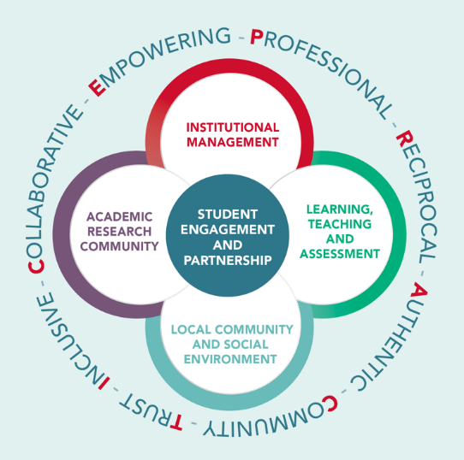  Figure 1  As outlined in the RCSI strategy 2023-2027 ‘Innovating for a Healthier Future’, the RCSI StEP programme is now at the core of providing a distinctive and transformational educational experience that sets students up for success at RCSI and as future graduates. It defines and drives student engagement and partnership across all campus activities and touch points in the student journey, positively contributing to RCSI’s institutional management and key decision-making processes, its educational and research programmes, local communities and social environment.  Since 2020-2021, 68 StEP Level 1 Funded Projects (10 week projects run during semester 2 with student contact capped at 3 hrs/week) and 41 StEP Level 2 Funded Projects (8 week full-time projects during the summer) have been completed with a total of 178 staff (academic and professional) and 171 students working in partnership on these projects. All student and staff partners received an RCSI Student Partnership Champion award certificate.  Six StEP Agreements (Figure 2) have been launched to date. These Agreements define how students and staff can work together by way of shared goals to shape our policies and practices, including the design and delivery of our education and research programmes, our student support systems, engagement with our wider communities, ultimately enhancing student success in RCSI.  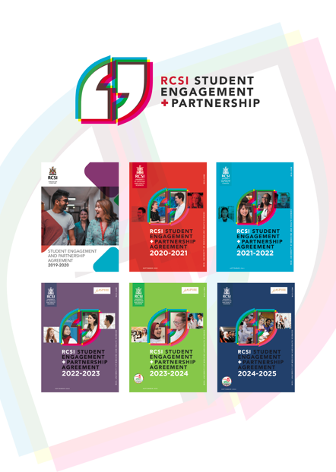  Figure 2  The student partnership philosophy extends to RCSI-Bahrain; they adopted RCSI’s StEP programme in November 2021.  As external validation of our university-wide culture of student engagement and partnership, RCSI was presented with the highly prestigious and internationally recognised AMEE ASPIRE-To-Excellence Award for Student Engagement in 2022. ‘The ASPIRE award programme was established to go beyond the traditional accreditation process, and to identify, recognise and reward world-class excellence in education’. RCSI was also awarded the Sunday Times University of the Year for Student Engagement 2022.
Did you collaborate with internal and/or external stakeholders to deliver? | The RCSI StEP Committee, comprising staff and student representatives and chaired by the Deputy Dean for Student Engagement, conducted a significant benchmarking exercise in which we reviewed and compared best practices in student engagement and partnership at a national as well as international level. This ultimately led to the establishment of the formal RCSI StEP programme.
Organisation and Planning | 2018: Launch of RCSI Strategy 2018-2022 in which student partnership was cited as a key strategy enabler  Sept 2018: Appointment of Deputy Dean for Student Engagement  Dec 2018: Establishment of RCSI StEP Committee  Oct 2019: Launch of first RCSI Student Engagement and Partnership Agreement  2020-2021: Launch of formal RCSI StEP Programme which included open calls for StEP-funded projects  The RCSI StEP programme has been running since then under the academic leadership of the Deputy Dean (2018-2024)  Oct 2020 - RCSI StEP Agreements launched annually  2023: Appointment of a staff member (0.2 FTE) to provide operational and administration support for the StEP programme  2024: Deputy Deanship tenure ended and a new appointment established: Academic Director of the RCSI Student Engagement and Partnership Programme
What resources did you need? | Financial resources are required annually to provide bursaries for students completing StEP-funded projects and to cover project costs.  Professional administration support is also required to provide operational and administration assistance.
Has it been evaluated? How successful has it been? | As external validation of our university-wide culture of student engagement and partnership, RCSI was presented with the highly prestigious and internationally recognised AMEE ASPIRE-To-Excellence Award for Student Engagement in 2022 following an external peer-review process. ‘The ASPIRE award programme was established to go beyond the traditional accreditation process, and to identify, recognise and reward world-class excellence in education’.  RCSI was also awarded the Sunday Times University of the Year for Student Engagement 2022.
Any future plans, including the sustainability of the initiative? | To support the sustainability of the StEP programme, a new appointment, Academic Director of the RCSI StEP Programme, was established in 2024. The Academic Director reports to the RCSI Deputy Vice-Chancellor for Academic Affairs.
Key Learning Points | The power and influence of student partnership and its far reaching impact. Students benefit, staff benefit and the wider university benefits.

Teaching and Learning Focus Areas (please tick all that apply)
Categories | Elements | Topics | Target Groups
Commit ☒ | Leadership, Strategy & Governance ☒ | Digital Transformation ☒ | Students ☒
Coordinate ☒ | Curriculum and Assessment ☒ | Education for Sustainable Development  ☒ | Staff ☒
Consult ☒ | Innovation in Teaching☒ | Academic Integrity  ☒ | Wider community ☒
Create ☒ | Professional Development ☒ | Inclusive and Equitable Teaching Practices  ☒ | Other ☒
Celebrate & Continue ☒ | Research and Evaluation ☒ | Innovations in Assessment and Feedback  ☒
Student Engagement and Partnership
☒

Collaborative and Interdisciplinary Approaches
☒

Artificial Intelligence
☒

Other : UN SDGs
☒

Contact Details
Contact Name/s | Professor Celine J. Marmion
Date | 15th November, 2024
Email Address | cmarmion@rcsi.com
Links | Please add links to any relevant pages/ documents. Please attach any items not in a link format with your submission.  RCSI strategy 2023-2027 ‘Innovating for a Healthier Future’  https://www.rcsi.com/dublin/student-life/student-engagement-and-partnership

