TEACHING AND LEARNING CASE STUDY
Name of Institution/ Organisation | Dundalk Institute of Technology
Who led the initiative? | Centre for Excellence in Teaching and Learning DkIT
Date and timeframe of the initiative | Academic year 2021 – 2022
What was the reach of the initiative? | The initiative targeted 34 first year Social Care students
Initiative Title | Involving 1st year students in the feedback process using Peer Reviews with no grading
Aims/ Objectives | To include students in the assessment process with the aim of giving them the opportunity to judge academic work(s) of their peers.
Rationale and Identified Needs | The main thinking behind this initiative was to prepare students to judge the quality of academic work and then to give them the opportunity to judge the quality of their peers’ works (and by extension their own). This would allow them to be a part of feedback process and more capable of using the feedback that was generated.
Frameworks, Policies, or Strategies Aligned  (internal, local or national) | Strategic Alignment of Teaching & Learning Enhancement (2020)
Summary | The case study took place over a 12-week period within the following timeline.  In week 2 of the module I spoke to the students about their CA & I presented the students with a marking rubric which we discussed (students completed a written reflection at the end of class). Following this, a week later, I provided two exemplars of two previous students’ work (high and low quality) to students and asked them to assess the quality of those exemplars using the rubric (students completed a written reflection at the end of class). In week four, I had students discuss the quality of those exemplars in class in small groups (each of which were recorded) and, a week later, I talked the students through the feedback I had provided on one of the exemplars which we then discussed (students completed a written reflection at the end of class). At this point students worked on a draft submission of their CA. Following their submissions students were provided with two anonymised peer drafts to review (but not grade) using the rubric. Once students completed their reviews the anonymised feedbacks were distributed to students. Students had approximately two weeks to work on their drafts following the feedback opportunities. Students submitted their final CA in week 12. In week 13 some students attended 2 focus groups and 14 students agreed to being interviewed.
  Week in Module | Activity
  Week Two | Introduction to Marking Rubric
  Week Three | Students Grading Exemplars
  Week Four | Students Discussing Exemplars
  Week Five | Feedback example & discussion
  Week Eight | Draft Submission by students
  Week Ten | Peer Reviews completed
  Week Twelve | Final submission by students
Did you collaborate with internal and/or external stakeholders to deliver? | The internal stakeholders were 34 first year students of a module I was teaching.
Organisation and Planning | The research related to this case study received the approval of the DkIT School of Business and Humanities ethics committee.
What resources did you need? | Several recording devices.
Has it been evaluated? How successful has it been? | Braun and Clarke’s (2006) approach to thematic analysis was employed and generated the themes illustrated in figure 1 (see below p.5). The analysis spanned several months ensuring a familiarity with the data (Denzin and Lincoln 2013) but also a critical questioning of it (Braun and Clarke 2022). The analysis moved beyond looking at the descriptive nature of the data to analysing what was important for student’s judgement of quality. The experience engaged the student’s decision-making and cognitive processes, but also occupied their emotions and involved them in checking behaviours. The judgements made by the students focused on the quality of the work. Students used comparisons with peer work, feedback, and their own work to confirm the quality of both their peer’s work, but more significantly, their own work. They were better able to judge quality, and additionally adjust their own work, while doing the peer review by combining the guidance, engagement, and judgement processes they experienced (see Figure 2, p.7).  In conclusion, the findings confirm that peer review does facilitate students in judging academic work, as suggested by Carless and Boud (2018). Moreover, it appears that students compare their own work to the work of their peers’ and against rubrics, by generating internal feedback, as suggested by Nicol (2021) and acting on that feedback. While the whole experience was found to be generally positive, many students also viewed it as difficult.
Any future plans, including the sustainability of the initiative? | I generally provide exemplars to students and ask them to grade those exemplars using the assessment criteria for the module. Where possible, I use formative assessment to afford students the opportunity to adjust their work.
Key Learning Points | Where possible, and early in any course, students should be given the opportunity to make judgements on the quality of academic work.

Teaching and Learning Focus Areas (please tick all that apply)
Categories | Elements | Topics | Target Groups
Commit ☐ | Leadership, Strategy & Governance ☐ | Digital Transformation ☐ | Students ☒
Coordinate ☐ | Curriculum and Assessment ☒ | Education for Sustainable Development  ☐ | Staff ☐
Consult ☐ | Innovation in Teaching☒ | Academic Integrity  ☐ | Wider community ☐
Create ☒ | Professional Development ☐ | Inclusive and Equitable Teaching Practices  ☐ | Other ☐
Celebrate & Continue ☐ | Research and Evaluation ☐ | Innovations in Assessment and Feedback  ☒
Student Engagement and Partnership
☐

Collaborative and Interdisciplinary Approaches
☐

Artificial Intelligence
☐

Other
☐

Contact Details
Contact Name/s | Conor McKevitt
Date
Email Address | conor.mckevitt@dkit.ie
Links | https://eprints.dkit.ie/id/eprint/839/1/Focus%20on%20Feedback.pdf (see page 12)

Figure 1. The themes and subthemes generated in the qualitative analysis of the data.

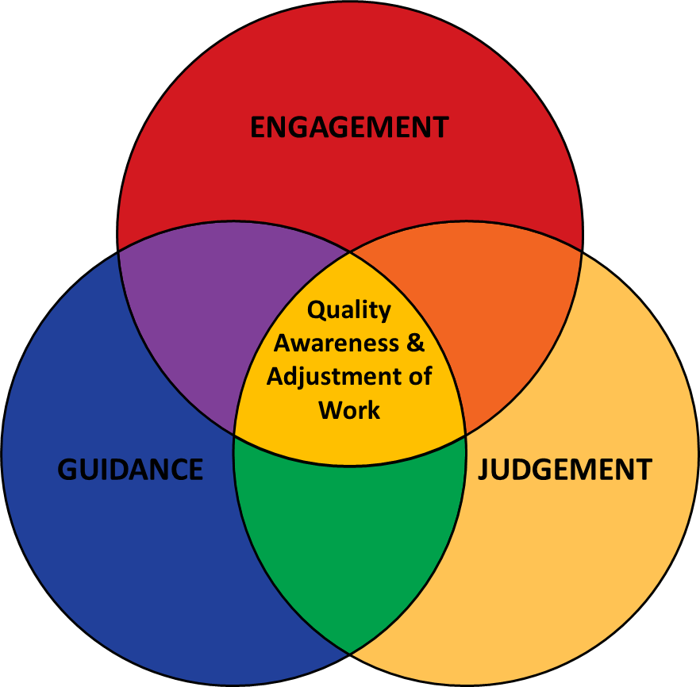

Figure 2. Overall qualitative themes and findings.

