TEACHING AND LEARNING CASE STUDY
Name of Institution/ Organisation | Dundalk Institute of Technology
Who led the initiative? | Department of Hospitality Studies / support from DkIT Centre for Learning and Teaching (CELT)
Date and timeframe of the initiative | Academic Year 2023 – 2024 (Semester 1) and ongoing.
What was the reach of the initiative? | BA (Hons.) in International Tourism Management students (10) and DkIT Institute Staff through an Institute Publication ‘You can UDL it’
Initiative Title | “Diversifying Assessment - Preparing the Next Generation for their Future - Hearing the Student Voice via an EduVlog”
Aims/ Objectives | To increase the inclusiveness of a module assessment.
Rationale and Identified Needs | From the outset, a core goal of this assessment was to be as inclusive as possible. The assessment was designed as ‘rethink’.  Multiple Means by Action and Expression is one of the ‘core’ 3 UDL principles. I decided the best way to begin embedding the principles of Universal Design for Learning (UDL) in my practice was to start small – taking a ‘plus-one’ approach.  Embedding UDL in my teaching, learning and assessment is an evolving and iterative process, so by making small incremental changes, I can increase the inclusiveness of one module assessment. I choose an EduVlog as a diversified type of assessment that can help to ensure that learning and assessment is more inclusive and engaging for students.
Frameworks, Policies, or Strategies Aligned  (internal, local or national) | Universal Design for Learning (UDL) is an educational framework based on research in the learning sciences, including cognitive neuroscience, which guides the development of flexible learning environments that can accommodate individual learning differences and cater for the wide range of diversity in our lectures and class-rooms, therefore our practices must also adapt to reflect the changing landscape of higher education.
Summary | I achieved the Universal Design in Teaching and Learning (UDL) Digital Badge and subsequently wanted to redesign some elements of my teaching and learning practice based on my newfound knowledge of the UDL principles. Higher education is increasingly supporting more diverse cohorts of students. Each student is unique. They are unique not only from their own personal knowledge, skills and competencies but they also come from a diversity of social and cultural environments. However, when it comes to assessment although there is a variety of different assessments used, it seems we are still very reliant on the essays, examinations, reports and oral presentations. I was interested in introducing a method of assessment that would incorporate visual materials and encourage creativity. This was introduced on the 10-credit module ‘Tourism Issues and Challenges’ on the BA (Hons) International Tourism Management Year 3.  The module includes: Visiting Guest Series: The series includes lectures and workshops from a range of industry professionals across the local and national tourism industry.  Student Led Presentations: The student led-taught sessions take place over a series of weeks for the entire semester, each incorporating a concept relating to international tourism issues and challenges.  Assessment included two oral presentations based on the students’ refection on these, weight 20% each.  Through PEC These were replaced by a single EduVlog (6-8 minutes reflecting on 6 topics/themes) weighted 40%. Students reflect using Gibbs’ Reflective Cycle which is a popular model for reflection, acting as a structured method to enable individuals to think systematically about the experiences they had during a specific situation.  I wanted to ensure that the module learning and assessment is more inclusive and engaging for students, this assessment specifically replaced a classroom-based face-to-face oral presentation. Students don’t need high-profile tools, they can create the EduVlog with a mobile phone and a Vlogging Kit. The 2023 cohort of students engaged very well with this assessment. Students posted their final EduVlogs on a private YouTube Channel.
Did you collaborate with internal and/or external stakeholders to deliver? | Students (internal)
Organisation and Planning | Students were given clear comprehensive instructions (assessment criteria and rubric) on all aspects of the planning, development and completion of the EduVlog assessment in Week 2 of the semester, and provided with Rode Vlogging Kit, compatible to their mobile phones.  Timeframe: 13 weeks (Semester One – Stage3)  EduVlog Assessment remained aligned with module learning outcomes.
What resources did you need? | Financial for Rode Vlogger Kit (SATLE Funding)  Time – researching on how to develop a Vlog for Education.
Has it been evaluated? How successful has it been? | EVALUATION:  To reflect on the effectiveness of the EduVlog assessment, I collected feedback from the student group – obtaining a 60% response rate.  Respondents strongly agreed that ‘Various assessments may not suit all students and we need to explore how the different approaches can be more inclusive for various student / student cohorts’.  Here are a number of quotation reviews from the student group.  “It’s fun, different and interesting”.  “It was a different way of completing an assessment which was interesting”. The thought of doing the EduVlogs was scary but at the end I quite enjoyed it, I mostly enjoyed the editing part”.  “I could explore and learn a new skill. I liked trying how to make the digital content, but I never did editing, it was a great way to try it out”.  “Applying new creativity and knowledge by creating my own vlogs. It was different than just sitting and writing an essay or report.”
Any future plans, including the sustainability of the initiative? | Semester One – Stage 3 the current cohort of students studying this module are completing the same EduVlog Assessment (with different topics of choice to reflect on their learning) for 2024.  Share practice: Share with colleagues the experience of engaging with UDL principles, with the students experience of an ‘inclusive, alternative assessment’.  Give students choice: For those who favour an oral face-to-face presentation, allow to ensure assessment is inclusive, that enables rather than hinders students learning/assessment.
Key Learning Points | - Engagement is essential for learning.  - Offering relevant, authentic options for assessment can help students transfer usable knowledge via the EduVlog.  - This assessment was designed alongside the module learning outcomes of the module so that I ensured the learning outcomes are achieved by the student.  - During the semester formative feedback were ongoing, and frequent checks in place to measure learners’ progress with the development of the EduVlog.  - The key to making this assessment more inclusive using Universal Design for Learning is choice, flexibility and transparency.

Teaching and Learning Focus Areas (please tick all that apply)
Categories | Elements | Topics | Target Groups
Commit ☐ | Leadership, Strategy & Governance ☐ | Digital Transformation ☒ | Students ☒
Coordinate ☒ | Curriculum and Assessment ☐ | Education for Sustainable Development  ☐ | Staff ☐
Consult ☐ | Innovation in Teaching☒ | Academic Integrity  ☐ | Wider community ☐
Create ☒ | Professional Development ☒ | Inclusive and Equitable Teaching Practices  ☒ | Other ☐
Celebrate & Continue ☒ | Research and Evaluation ☐ | Innovations in Assessment and Feedback  ☐
Student Engagement and Partnership
☒

Collaborative and Interdisciplinary Approaches
☐

Artificial Intelligence
☐

Other
☐

Contact Details
Contact Name/s | Karen Commins
Date | 15th November 2024
Email Address | karen.commins@dkit.ie
Links | Please add links to any relevant pages/ documents. Please attach any items not in a link format with your submission.  Dundalk Institute of Technology Publication collection brings together case studies from educators across DkIT, who have successfully implemented Universal Design for Learning (UDL) in their own practice. UDL provides a framework for making learning, teaching and assessment more inclusive, and helps to support all our students to thrive: You can UDL it - DkIT Publication.pdf  Sample EduVlog Assessment: on Private YouTube Channel.  https://www.youtube.com/playlist?list=PLVcls1xNdiCwNwpu-1RakjihKQSQFQpD5  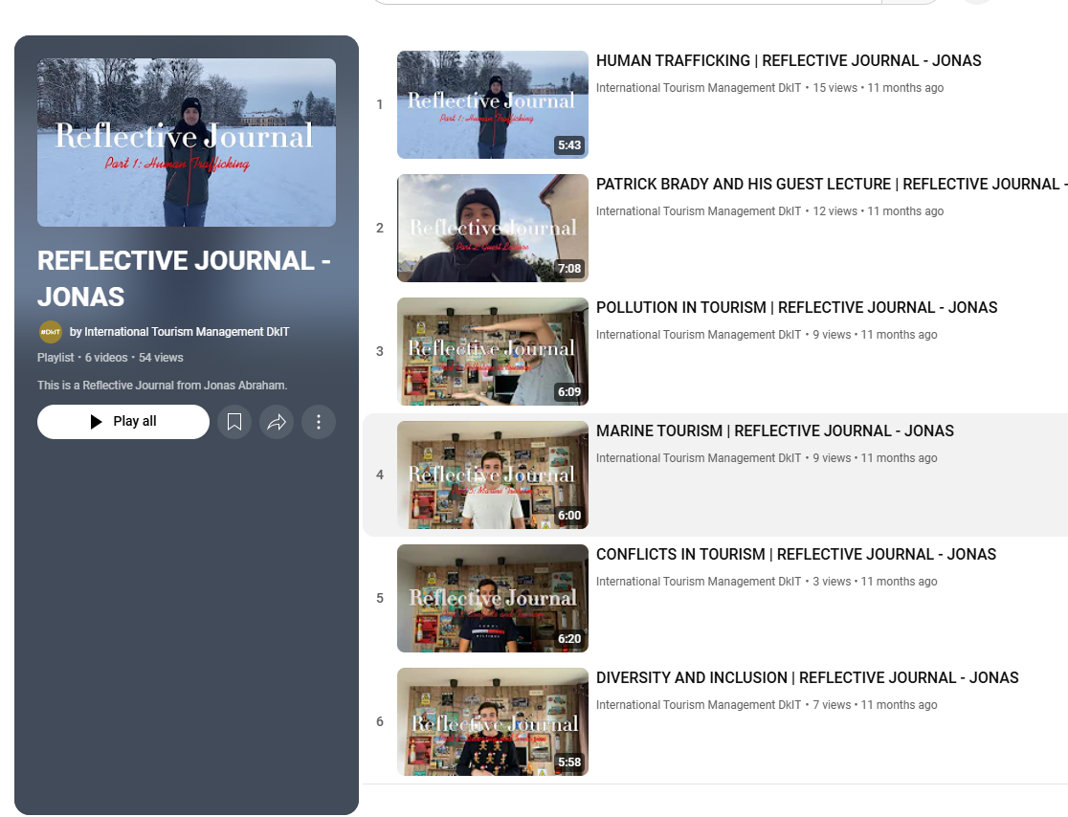  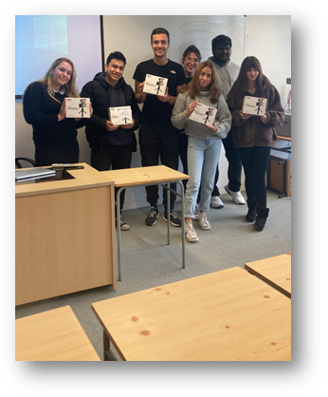  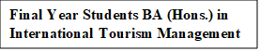  Permission received to publish photo image via Feedback Survey 16th January 2024.  