TEACHING AND LEARNING CASE STUDY
Name of Institution/ Organisation | Dublin City University
Who led the initiative? | Office of the Vice President for Academic Affairs and Teaching Enhancement Unit
Date and timeframe of the initiative | 2023 onwards
What was the reach of the initiative? | University wide
Initiative Title | SATLE Snapshots: Insights into a blended approach to SATLE Initiatives at DCU.
Aims/ Objectives | Aim: to support and scaffold SATLE related initiatives at DCU via three anchor posts related to Academic Integrity; Educations for Sustainable Development and Digital Transformation.  Objectives:  - to provide a core, consistent and pedagogically grounded approach to teaching, learning and assessment development and practice in the three thematic areas  - to facilitate the integration and cross over of activity in the three areas as relevant and appropriate  - to facilitate the creation of communities of practice which would nurture creativity and create opportunities for action
Rationale and Identified Needs | As highlighted above, an integrated approach to SATLE activity at DCU under three main themes of Digital Transformation, Education for Sustainable Development, Academic Integrity could best be facilitated and supported by leveraging the existing philosophy and modus operandi of the Teaching Enhancement Unit (TEU). Conscious of the need to respond to individual Faculty/School/Programme needs and to support those at different stages of the thematic journeys, the roles of Academic Integrity Officer, Education for Sustainable Development Officer and Learning Technology Analyst are based in the TEU. The work of the role holders has been a catalyst for creativity and development of practice as outlined in some key examples below.
Frameworks, Policies, or Strategies Aligned  (internal, local or national) | - DCU Strategy 2023-2028 Transformation for an Unscripted Future  - Faculty level Teaching & Learning Strategies  - The National Professional Development Framework for All Staff Who Teach in Higher Education  - National Forum Guide to Developing Enabling Policies for Digital and Open Teaching and Learning  - NAIN Academic Integrity Guidelines  - NAIN Generative Artificial Intelligence: Guidelines for Educators
Summary | The roles ensure a consistent and balanced approach to development in the three thematic areas. The roles surface and highlight current exemplars of practice, strengthen and support curricular development, and provide professional development opportunities and resources for staff.  The roles have also supported initiatives which have been implemented as part of targeted Faculty funding and small-scale funding for Learning Enhancement Projects. As the initiatives developed to date cover a broad range of areas, we highlight below an example from each thematic area:  Education for Sustainable Development  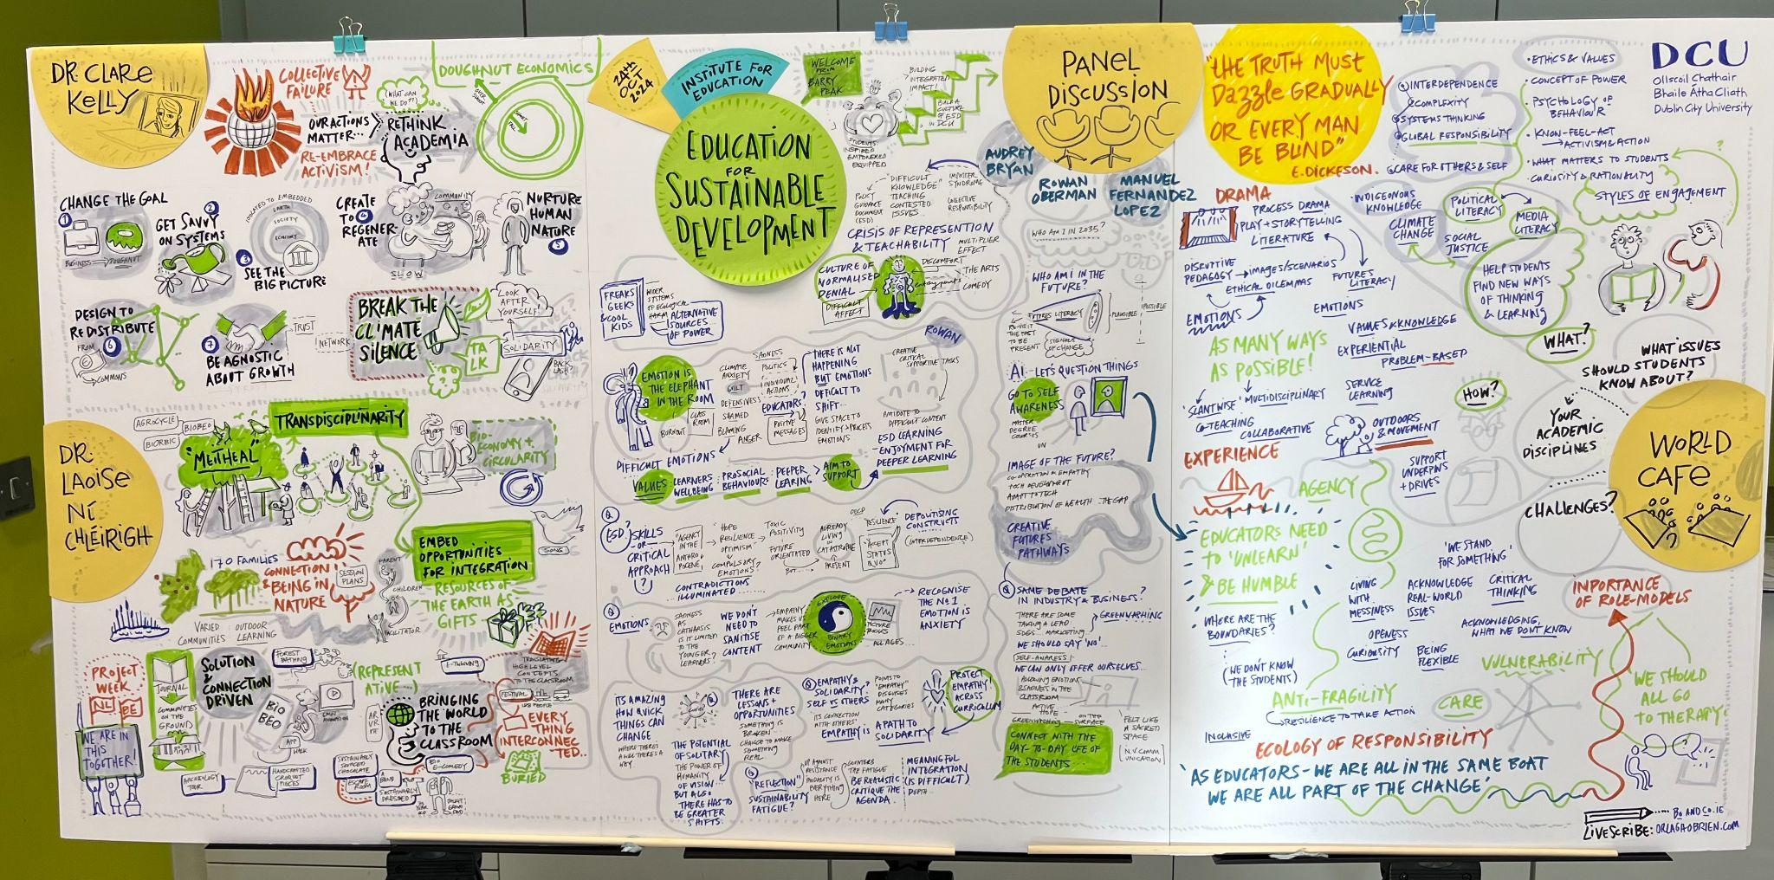  An ESD Day was an opportunity for all staff at the Institute of Education to come together, consider the theory and practice of ESD, and identify next steps to further integrate it into teaching and learning. Two keynote speakers addressed the increasingly significant role ESD must play in HEIs in the context of a planetary polycrisis. A panel discussion and a world café event allowed staff to identify practical steps they can take to weave ESD content and pedagogies into their work.  Digital Transformation  A specific focus on professional development for lecturers on the use of the Accessibility Toolkit within the Virtual Learning Environment (VLE). This is an essential resource within the VLE, designed to help educators analyse and repair their learning material to ensure it is accessible. Resources have been developed to support the effective use of the toolkit to ensure learning materials on module page are inclusive and accessible to all students.  Academic Integrity  The Faculty of Science and Health hosted a two-day event aimed at providing guidance on teaching, learning, and research in response to GenAI. Invited speakers included a tech industry speaker, an assessment expert, and members of faculty. The TEU also shared assessment redesign strategies in response to GenAI. Faculty showcased various practices of assessment redesign, guided by TEU guidelines. The Academic Integrity Officer participated in a panel discussion with the invited speakers to explore the challenges and opportunities posed by Generative AI in teaching, learning, research, and industry.  An integrative activity  Several activities have been designed to promote a focus on the integrative elements of the three themes, particularly as they apply to approaches to teaching, learning and assessment. Key amongst these was an Activating Active Learning Hackathon. Staff participants from across all DCU faculties and a range of professional services units worked alongside expert mentors and students to investigate and provide actionable solutions for active learning in teaching.
Did you collaborate with internal and/or external stakeholders to deliver? | Ongoing collaboration with all internal stakeholders (staff and students).  External Guest speakers at events and external mentors at hackathon.
Organisation and Planning
What resources did you need?
Has it been evaluated? How successful has it been? | Many individual projects and initiatives have begun the next phase of evaluating the implementation of projects. We have also highlighted opportunities for funding evaluation of projects in our current project funding call.
Any future plans, including the sustainability of the initiative? | - A move to continuing integrated impact within Schools and Faculties.  - Successful initiatives will be replicated in other Schools and Faculties  - Continued support initiatives aimed at delivering professional and curriculum development.  - Communities of practice established to share good practice and allow ‘leaders’ within the spaces to share their learning.  - Collaborating with other HEIs in Ireland to allow academics from different faculties to share ideas and collaborate on future projects.  - An increased focus on impact and the Scholarship of Teaching & Learning leading to dissemination of learning.
Key Learning Points | - There is considerable existing good practice, which can be shared both within and between Schools and Faculties  - Many academics are already integrating themes such as sustainable development into their practice but may not be framing it as such.  - Tailored responses that reflect the needs of each Faculty are essential.  - An appreciation of the time pressure on academics is vital; therefore, initiatives must be sympathetic to their needs and involve focused, tailored initiatives.  - It is important to stress best practice methodologies and pedagogies in the support of professional development.  - Guided by local, university-wide, national, and international strategies on academic integrity.  - Importance of creating and maintaining local and cross-institutional communities of practice or similar events to support, advise, discuss, and share solutions to challenges.  - Student partnership is key

Teaching and Learning Focus Areas (please tick all that apply)
Categories | Elements | Topics | Target Groups
Commit ☐ | Leadership, Strategy & Governance ☐ | Digital Transformation ✓ | Students ☐
Coordinate ✓ | Curriculum and Assessment ✓ | Education for Sustainable Development  ✓ | Staff ✓
Consult ✓ | Innovation in Teaching✓☐ | Academic Integrity  ✓ | Wider community ☐
Create ✓ | Professional Development ✓ | Inclusive and Equitable Teaching Practices  ✓ | Other ☐
Celebrate & Continue ☐ | Research and Evaluation ☐ | Innovations in Assessment and Feedback  ☐✓
Student Engagement and Partnership
☐

Collaborative and Interdisciplinary Approaches
✓
Artificial Intelligence
☐✓

Other
☐

Contact Details
Contact Name/s | Dr Monica Ward; Dr Martina Crehan; SATLE Post holders Barry Peak; Jiaxin (Samantha) Xu; Motasem Al Haj Ali. Activities described above also represent the work of Faculty members across the university and members of the Teaching Enhancement Unit.
Date | November 13th 2024
Email Address | martina.crehan@dcu.ie can be contacted for any questions
Links | Relevant links highlighted in text.

