TEACHING AND LEARNING CASE STUDY
Name of Institution/ Organisation | Atlantic Technological University (ATU)
Who led the initiative? | Teaching & Learning Centre
Date and timeframe of the initiative | Academic year 2022 – 2024 and ongoing.
What was the reach of the initiative? | - The Assessment Resource Directory is open access on DigitalEd.ie and linked in the ATU Teaching and Learning SharePoint.  - Students: The Let’s Talk about Assessment workshop was run with three groups of students in preparation for work placement in the academic year 23-24. Between the three workshops there were 50+ students in attendance. Furthermore, the A-Z cards and workshop details were provided to the staff teaching on these programmes to continue to run this workshop with future students.  - Staff: The Let’s Talk about Assessment was run both in-person and online across ATU. The in-person workshops were run on six of the nine ATU campuses and the online version was offered to all of ATU. The engagement with this workshop was approximately 70 members of staff.  - A-Z Assessment Types cards – These cards were distributed and used as a supporting resource for ATU’s Assessment Hackathon which was hosted by the N-TUTORR project team. In addition to giving the cards to the hackathon and workshop attendees, the A-Z cards have been distributed at T&L events, conferences, and workshops.
Initiative Title | A-Z of Assessment Types Resource and Workshop
Aims/ Objectives | - To create a one-stop shop for assessment resources and a detailed list of assessment types to support colleagues when developing or redesigning assessment practices.  - To foster a community of practice around sharing and discussing various assessment types.  - To provide opportunities for interdisciplinary discussion on the use and application of assessment types.  - To support the education of future teachers by showcasing a diverse range of assessment types that could be incorporated into their future teaching practices.
Rationale and Identified Needs | - Community of Practice: This initiative aimed to create a collaborative environment for educators to share ideas, experiences, and knowledge of assessment practices.  - One-stop-shop: To create a one-stop-shop for assessment resources and make them easily accessible to educators.
Frameworks, Policies, or Strategies Aligned  (internal, local or national) | - ATU’s Teaching and Learning Strategy
Summary | This initiative was part of the ATU Re-imagining Assessment and Feedback for Student Success project which was funded by the National Forum for the Enhancement of Teaching and Learning in Ireland under SATLE funding. The development of the suite of assessment resources and A-Z of assessment types list was carried out in the first phase of this project (22-23). In addition to the development of the suite of resources, an assessment masterclass series was run online and was accessible to all staff in ATU. The recordings and slides from each of the masterclass sessions are available to view within the assessment resource directory.  In the second phase of the project the A-Z list was further expanded to include more in-depth details about each of the assessment types such as tips for using, advantages and challenges, links to further resources, and sample rubrics. Additionally, this list of assessment types was transformed into a deck of cards that can be diverse in their application. Initially, these cards were used at the ATU Assessment Hackathon as a supporting resource, this event was organised by the N-TUTORR Transforming Learning team. The Hackathon was run simultaneously in three locations (Galway, Sligo and Donegal). Each participant received a deck of the A-Z Assessment Types cards. The cards have been distributed to many staff members in ATU through events and conferences. An online PDF version is linked on the Assessment Resource Directory and is available to download.  Furthermore, the Let’s Talk about Assessment workshop was developed around the application of these A-Z Assessment Types cards. This interactive workshop provides the opportunity for participants to randomly select different assessment types and consider how they could apply them to their own subject area. This is followed by a group discussion, which provides the opportunity for sharing of ideas and practice. The workshop was further developed into different formats, originally it was delivered as a one-hour face-to-face workshop with staff. The variations include an online version, a 90-minute version which included considering adaptions to assessment types in response to the use of Generative AI, and a face-to-face workshop for students in preparation for work placement.
Did you collaborate with internal and/or external stakeholders to deliver? | ATU Teaching and Learning Centre, ATU Re-imagining Assessment and Feedback for Student Success project team, and N-TUTORR Transforming Learning project team.
Organisation and Planning | The development of the Assessment Resource directory consisted of evaluating the resources that ATU have and compiling them into one designated area. In the initial stages the projected team identified what sections would be included. The original A-Z list consisted of the name of the assessment and a brief description of what it is. In the second phase it was decided that we wanted this list to be more comprehensive and include additional supporting information.  The workshop was firstly run with a small group of staff members on the Certificate in Teaching and Learning on the Galway City campus. As a result of this pilot amendments were made to the workshop including changes to the timing of activities and clearer terminology and prompts.
What resources did you need? | - This initiative was funding as part of the Re-imagining Assessment and Feedback for Student Success project by the National Forum for the Enhancement of Teaching and Learning under SATLE funding. The initiative was also supported through funding by the N-NUTORR Transforming Learning project.  - The webpage and cards were designed by an external design company. The cards were also printed by an external company.
Has it been evaluated? How successful has it been? | - A feedback survey was distributed to colleagues who took part in the Let’s Talk about Assessment workshops. The responses were all positive.  - Additionally, the lecturers who work with the students in preparation for work placement passed on positive feedback to the project team about the workshop.
Any future plans, including the sustainability of the initiative? | - The Assessment Resource directory will be continued to be updated with resources. All resources including the PDF version of the cards are accessible on the DigitalEd platform.  - The workshop details and A-Z assessment cards have been shared with the lecturing staff on the education programmes in ATU Wellpark Road and Letterfrack campuses. The workshop will continue to be run on these programmes.
Key Learning Points | - The importance of having a space for educators to come together to share and discuss ideas in relation to assessment practices.  - That having a “one-stop-shop” or central hub for assessment improves to ease of access to resources.  - Educators appreciate the opportunities to engage and learn from colleagues from similar or different disciplinaries.

Teaching and Learning Focus Areas (please tick all that apply)
Categories | Elements | Topics | Target Groups
Commit ☐ | Leadership, Strategy & Governance ☐ | Digital Transformation ☒ | Students ☒
Coordinate ☒ | Curriculum and Assessment ☒ | Education for Sustainable Development  ☐ | Staff ☒
Consult ☐ | Innovation in Teaching☐ | Academic Integrity  ☐ | Wider community ☐
Create ☐ | Professional Development ☒ | Inclusive and Equitable Teaching Practices  ☐ | Other ☐
Celebrate & Continue ☐ | Research and Evaluation ☐ | Innovations in Assessment and Feedback  ☒
Student Engagement and Partnership
☐

Collaborative and Interdisciplinary Approaches
☒

Artificial Intelligence
☐

Other
☐

Contact Details
Contact Name/s | Emma McDonald
Date | 15/11/2024
Email Address | Emma.mcdonald@atu.ie
Links | Assessment Resource Directory: Assessment Resources - Digital Ed  A-Z Assessment Types Resource and Cards: Assessment Types - Digital Ed  Assessment Resource directory:  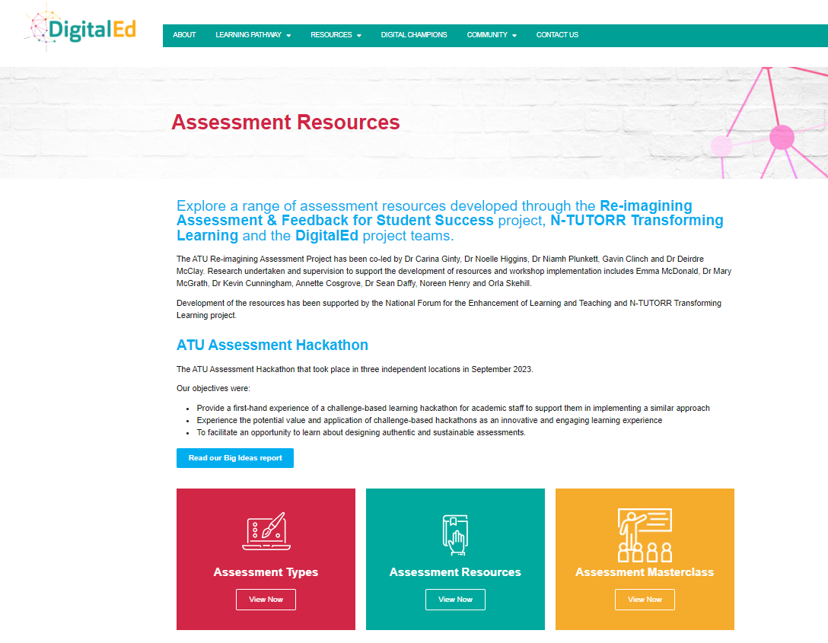  Assessment cards:  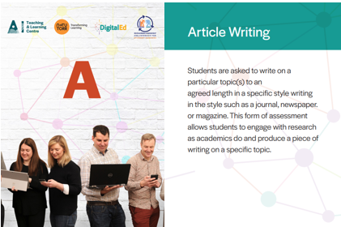  A-Z of Assessment Types:  