TEACHING AND LEARNING CASE STUDY
Name of Institution/ Organisation | Atlantic Technological University (ATU)
Who led the initiative? | ATU UDL Centre of Excellence – supported by ATUs Teaching & Learning Department led the initiative, AHEAD were Lead Collaborators.
Date and timeframe of the initiative | December 2022- June 2024
What was the reach of the initiative? | Consultation has been a crucial aspect of the development, involving internal consultation with a 50+ member expert group, a national consultation event, 30+ staff and learner focus groups, 1300+ learner survey responses and a stakeholder dialogue process.
Initiative Title | ALTITUDE – The National Charter for Universal Design in Tertiary Education
Aims/ Objectives | The ALTITUDE project set forth three key outputs:  - Development of the ALTITUDE Charter to initiate a national discussion on its adoption and support.  - Production of a Position Paper outlining charter development and proposing how it may be adopted and utilized in the system.  - Adaptation and update of the Toolkit for Inclusive Higher Education Institutions (Kelly and Padden, 2018) to support self-assessment and practical implementation of the ALTITUDE Charter by Higher Education Institutions (HEIs) and Education and Training Boards (ETBs) across the tertiary sector.  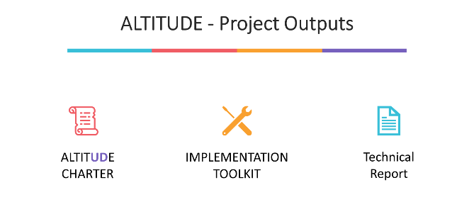  The ALTITUDE Charter aims to provide a systemic implementation roadmap for UD and related frameworks in tertiary education, acting as a commitment vehicle for institutions.
Rationale and Identified Needs | Despite a robust national policy commitment to a UD approach, evidence suggests that this commitment is not always consistently reflected in the institutional strategies and or practices in tertiary education sector. This discrepancy raises concerns about the sustainability of the UD approach within tertiary education sector.  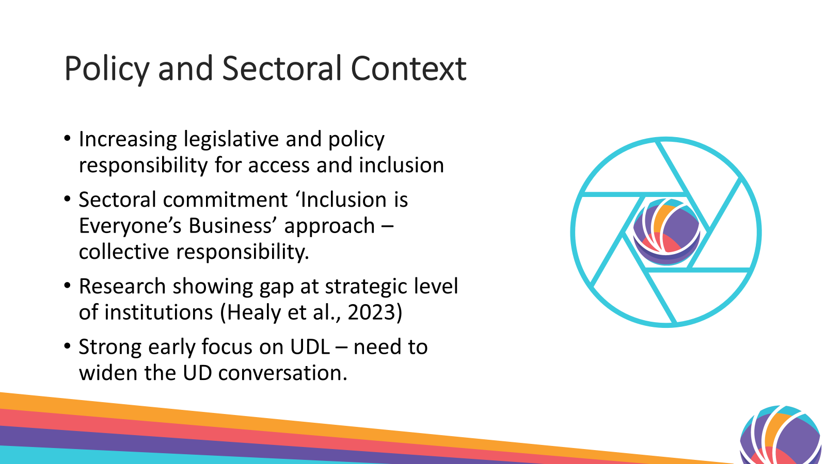  In response to the need for a more inclusive tertiary education system, calls for the development of a National Charter for Universal Design in Tertiary Education emerged.
Frameworks, Policies, or Strategies Aligned  (internal, local or national) | 1. UNCRPD Article 24: Emphasizes the significance of Universal Design (UD), UDL, and inclusion in achieving the right to education.  2. UN Sustainable Development Goals (SDGs): Goals 4 and 10 aim to ensure inclusive, equitable quality education and lifelong learning opportunities for all.  3. National Access Plan:  Ambition Statement: Advocates for higher education institutions to be inclusive and universally designed to support student success, equity, and diversity.  Objective 1.3: Focuses on embedding universal design across institutions to foster student success.  4. Progressing a Unified Tertiary System for Learning, Skills, and Knowledge: Supports the integration of UDL in tertiary education.  5. Irish Legislation (EPSEN, Equal Status Acts, Disability Act 2005): Provides a legal framework supporting the initiative's goals.  6. ATU – AQAE004 – Programme Design Policy, Universal Design 4.7.7, 4.8.1  7. ATU Strategic Plan - Enabling Education for Student Succes, Vision 2040 (2024-2028)
Summary | The project involves a diverse array of stakeholders, including national bodies, HEIs, and ETBs encompassing an extensive collaboration with a 27-strong cross-sectoral partnership. Workload and responsibilities have been distributed among ten working groups at different project stages.  The project's goals, outlined in the working draft, are to:  • Provide a vehicle for HEIs and ETBs (institutions) to declare their intent to make incremental and sustainable progress towards embedding a universal design approach, in line with their resources, culture and strategy.  • Promote the development of institutional policies, structures, and strategies which support the sustainable implementation of a universal design approach across tertiary institutions.  • Anchor a culture of shared responsibility for universal design, access & inclusion across the tertiary sector by developing organisational structures which foster an ‘everyone’s business’ approach to inclusion.  • Develop a more unified language of and commitment to a universal design approach across the tertiary sector, fostering greater opportunities for partnership, collaboration and shared learning.  • Support institutions to work towards goals in a range of key national and international strategies concerning universal design, student success, sustainability, and inclusion.  Signing the ALTITUDE Charter will signal an institutions' positive intent to make gradual and lasting strides in embracing a UD approach. Acknowledging diverse institutional stages and resources, the Charter promotes steady progress aligned with each institution's strategies and values. Committing to the Charter involves establishing a remit in each institution to oversee the implementation of UD across the four pillars outlined in the Charter as a singular new committee or within existing structures.  The development of the ALTITUDE Charter is informed by international literature on UD in educational contexts and extensive consultation with staff and learners in Irish tertiary education. The Charter recommends key strategic foundations and scaffolding for institutions to support the sustainable implementation of universal design across the learner experience.  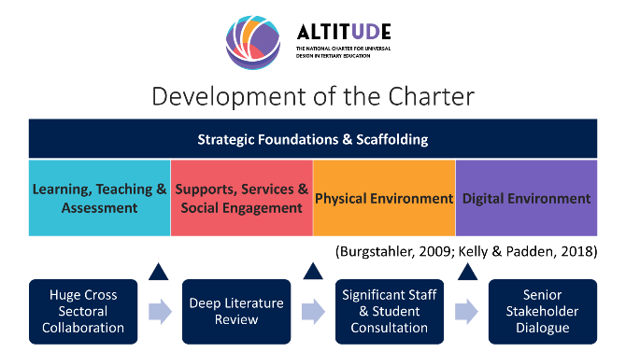
Did you collaborate with internal and/or external stakeholders to deliver? | The project team involves a diverse array of stakeholders, including national bodies, HEIs, and ETBs encompassing an extensive collaboration with a 27-strong cross-sectoral partnership.  - ETBI, National Forum, DFHEIRS, HEA, SOLAS, IUA, THEA, Student Unions within Institutions, NTO, QQI, DAWN, CEUD, Department Heads within institutions  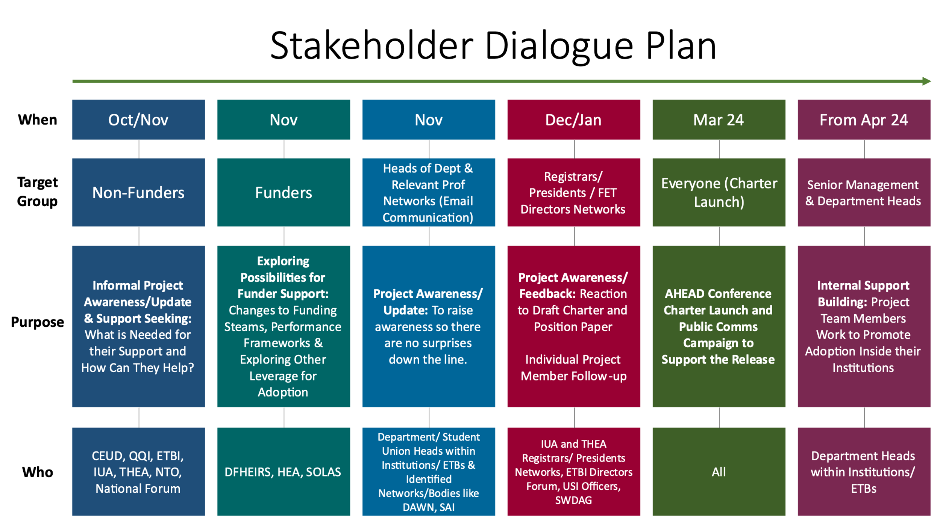
Organisation and Planning | Charter Team  • National Charter Team Official Partners & Regional Collaborators: ATU (lead), MTU, U of G, UCD (partners), 10 other HEIs (collaborators), 6 ETBS representing the sector. National Agency Collaborators: AHEAD (Lead Collaborators) ETBI, IUA, THEA, SOLAS, NTO.  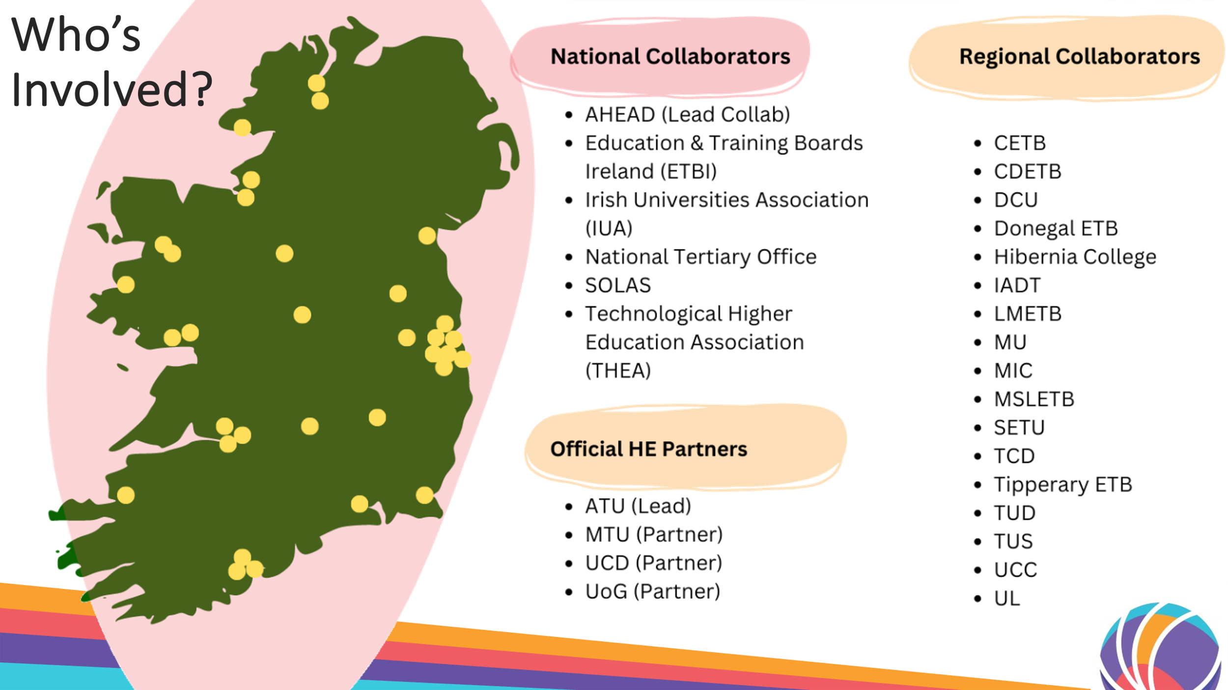  • Monthly meetings from December 2022-April 2024. These meetings progressed consultations and charter draft stages.  • Technical Report (subcommittee working group) met regularly to progress the Technical Report outlining the charter development and proposals on how it may be adopted and utilised in the system.  Consultation(s)/ Draft Stages:  • Phase 1: Internal consultation with the 50+-member expert group (Dec 22-Feb 24).The first consultation - National UD Charter team. UCD Inclusive Toolkit from 2018 (reviewing the 4 pillars; teaching & learning, student supports & services, physical environment, digital environment) reviewed, 162 gaps identified. From this consultation draft 1 of the charter was created.  •Phase 2: A 2-day national consultation event built into the AHEAD conference featuring 200+ students and professionals from FET and Higher Education (Mar). Following phase 1 and 2, an early draft of the charter was developed to inform the next phase of consultation.  • Phase 3: 20 focus group staff consultations facilitated locally in ETBs and HEIs around the country by project team members, providing direct feedback on the draft Charter (May to July).  • Phase 4: 15 learner focus groups and approx. 1350 learner survey responses providing direct input from FET and HE students on what would make their experience more inclusive and accessible in each pillar  • Phase 5: Consultations/ Stakeholder Dialogue: The National UD Charter project Lead and Collaborative Lead held various key stakeholder groups and invited further consultation opportunities. Each of the stakeholders named below participated in ALTITUDE Charter consultations prior to the next phase of the draft process. (QQI, IUA Registrars, THEA Registrars, ETBI – Inclusion & Strategy Committee, SOLAS, National Forum, NTO, DAWN Network)  • Phase 6: Development of final draft of the Charter and Technical Report, considering the findings of phase 4 and 5 consultations in updates made.  • Launch of the Charter and Technical Report as a national discussion in March 2024, with the toolkit following by UCD partners in June 2024. These releases were intended to give institutions an early look at the Charter and encourage internal dialogue to consider formal adoption and implementation.  • Given the need for deeper dialogue with representative groups and policy makers, it is estimated that adoption of the Charter will formally become early 2025.  UCD Toolkit  • Student & Staff consultation data facilitated by the National Charter team assisted in informing the re-development of the UCD Toolkit for Inclusive Higher Education Institutions (Unlocking Inclusion Toolkit) released June 2024.
What resources did you need? | National Access Plan PATH 4 Phase I funding allowed for lead and partnering institutions to utilise funding to contribute staffing hours and data analysis resources. Expertise within the Charter team was utilised and considerable progress in development has been made considering the funding was not substantial. The significant progress has been facilitated by an extraordinary collaborative effort from the cross-sectoral team, and the distribution of workload and responsibility to 10 different working groups at different stages of the project to date.
Has it been evaluated? How successful has it been? | At every draft phase, the ALTITUDE project team (52 colleagues with UD/ UDL expertise across FET/ HE evaluated the Charter. The content of the Charter has been evaluated via staff/ student consultations.
Any future plans, including the sustainability of the initiative? | - Encouraging Institutional Adoption  - ALTITUDE Community in Development  - National Adoption Process Development – Senior Stakeholder Group being formed
Key Learning Points | - By the sector, for the sector!  - Prioritises iterative transformation over time  - Not replacing existing frameworks – but embedding them!  - Collaboration between existing key functions on UD!  - Commitment to the journey, not the destination!  - Open source – creative commons.

Teaching and Learning Focus Areas (please tick all that apply)
Categories | Elements | Topics | Target Groups
Commit ☒ | Leadership, Strategy & Governance ☒ | Digital Transformation ☒ | Students ☒
Coordinate ☒ | Curriculum and Assessment ☒ | Education for Sustainable Development  ☒ | Staff ☒
Consult ☒ | Innovation in Teaching☒ | Academic Integrity  ☒ | Wider community ☒
Create ☒ | Professional Development ☐ | Inclusive and Equitable Teaching Practices  ☒ | Other ☐
Celebrate & Continue ☒ | Research and Evaluation ☒ | Innovations in Assessment and Feedback  ☐
Student Engagement and Partnership
☒

Collaborative and Interdisciplinary Approaches
☒

Artificial Intelligence
☐

Other
☐

Contact Details
Contact Name/s | Maureen Haran. Niamh Plunkett
Date | 08/11/2024
Email Address | maureen.haran@atu.ie  niamh.plunkett@atu.ie
Links | ALTITUDE Project Webpage

